**Task AWS restart/program Name: Nandagopal K**

***Task 1.Convert .pem keypair to .ppk***

**Step 1:** Download Putty and puTTYgen

Step 2: Open the putTTYgen and navigate to Load button

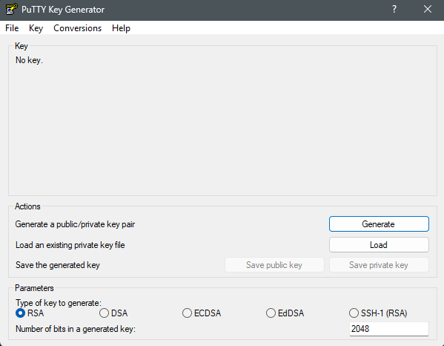

**Step3**: Select the pem file which you had already created

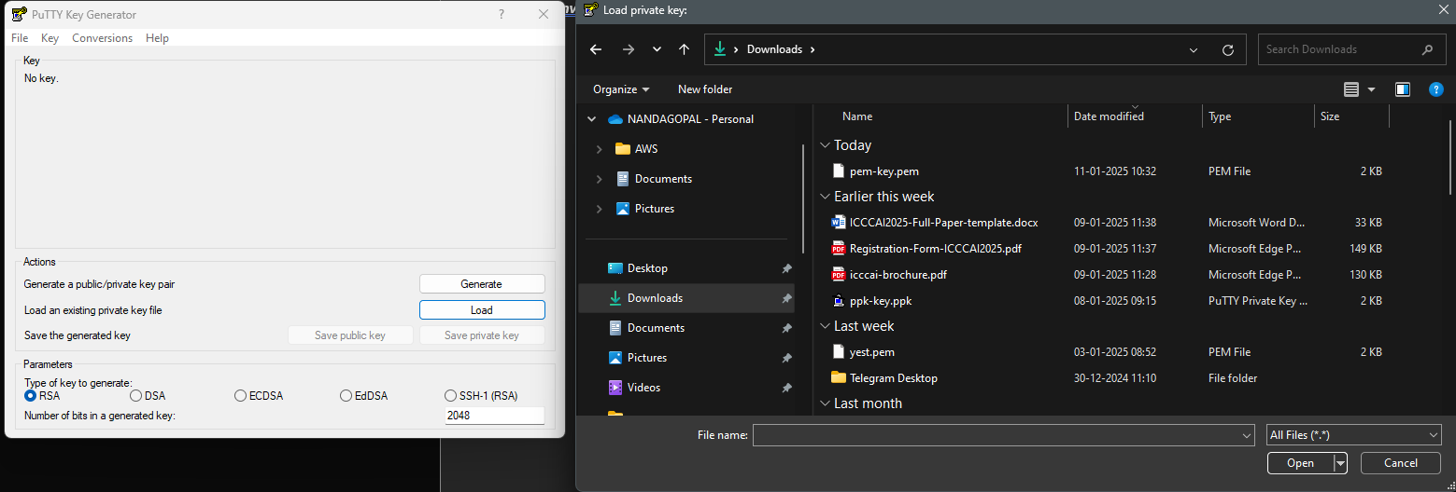

**Step 4:** once the .pem file is loaded a successful pop up message will be given and that shows to *save the pem private file as putty private file.*

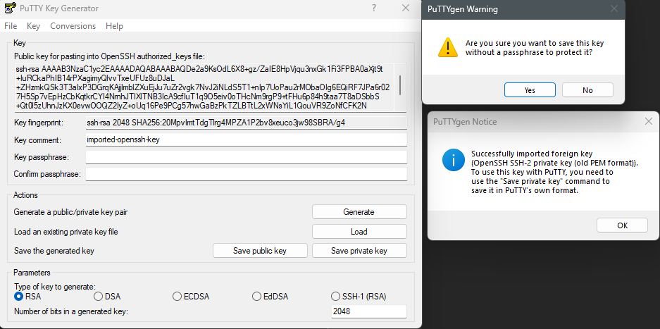

Step 5: Give the naming conversion for the new converted file and then you had successfully converted a pem file into a ppk file.

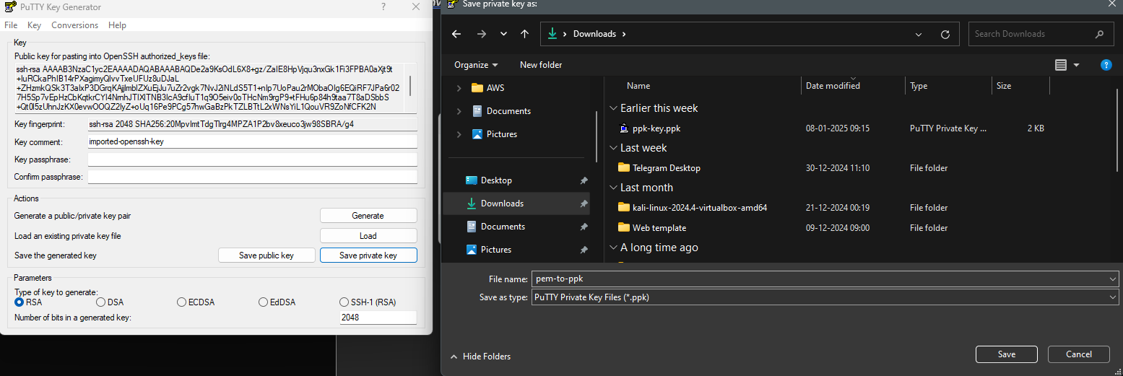

***Task 2*** : **Convert .ppk file to .pem file**

**Step1: Install puTTYgen and navigate into the software**

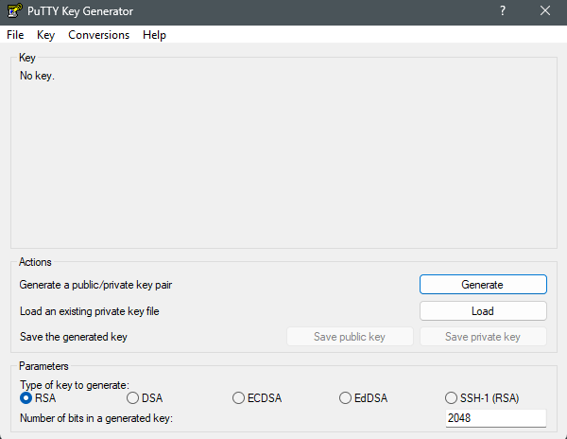

**Step 2**: Click on conversions and there will be a load option and click on load

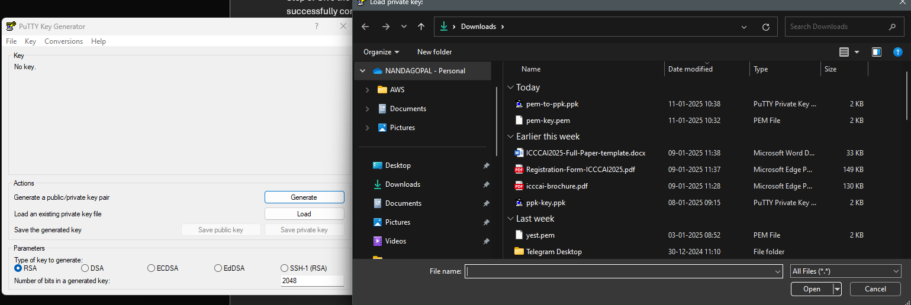

**Step 3** : one the .ppk file is loaded if you need a key passpharase you can apply it or else leave it as blank it is nothing but an password for creating a new .pem file

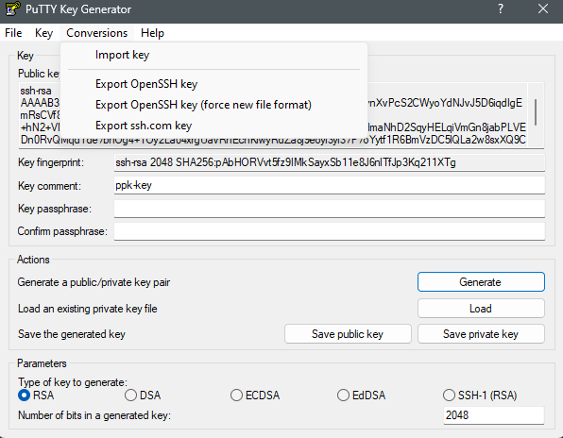

**Step 4:** Go to conversions and click Export OpenSSH Key and then export it as .pem file

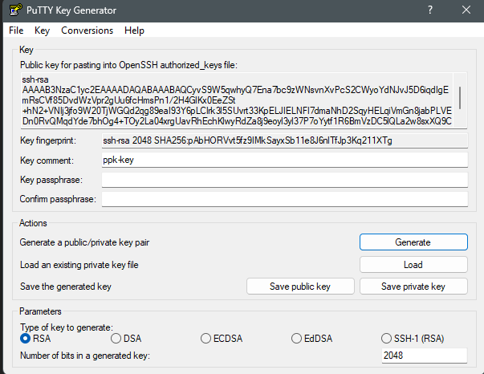

Step 5: The output of the .ppk to pem resembles like this and it is important to note that the file has begin with *RSA PRIVATE KEY* and *END RSA PRIVATE KEY*

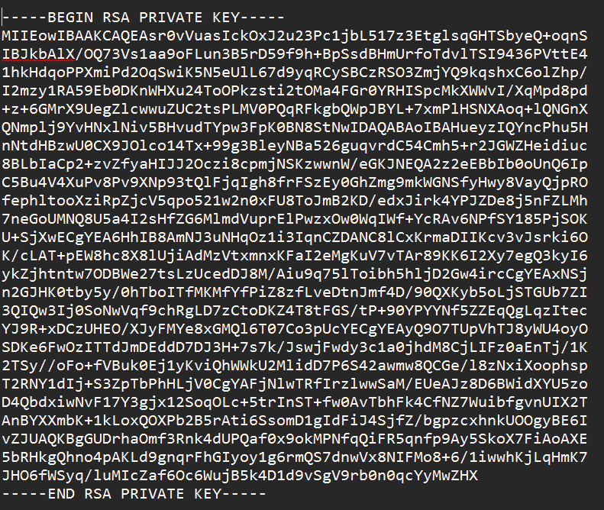

***Task 3***: ***Enable Deletion Protection for instances***

**Step 1**: Create an instance with a name , ami, keypair, volume, security group, and leave all the other settings as default and click the launch button.

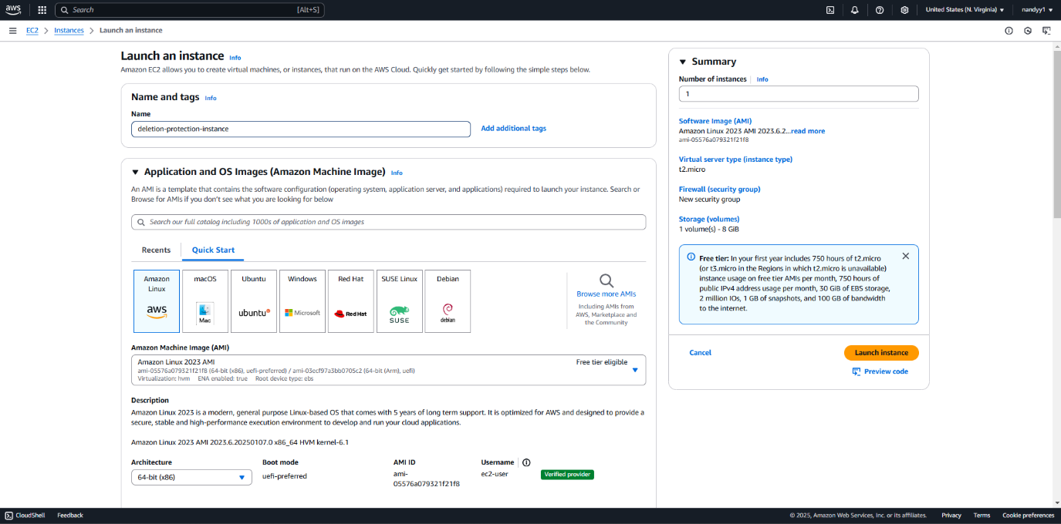

**Step 2**: click on Actions and instance settings and in the dropdown menu click change termination protection 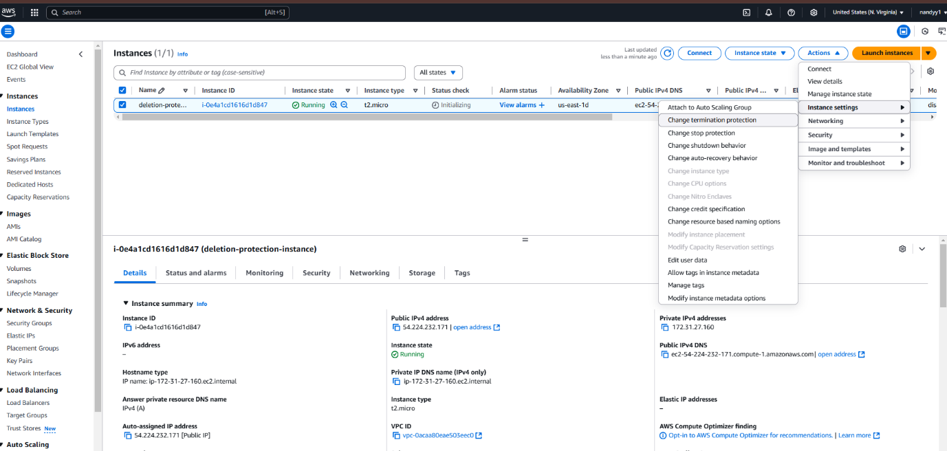

**Step 3**: Check the Enable button this buttons shows that if any accidental deletion occurs on the instance means the instance will not get deleted.

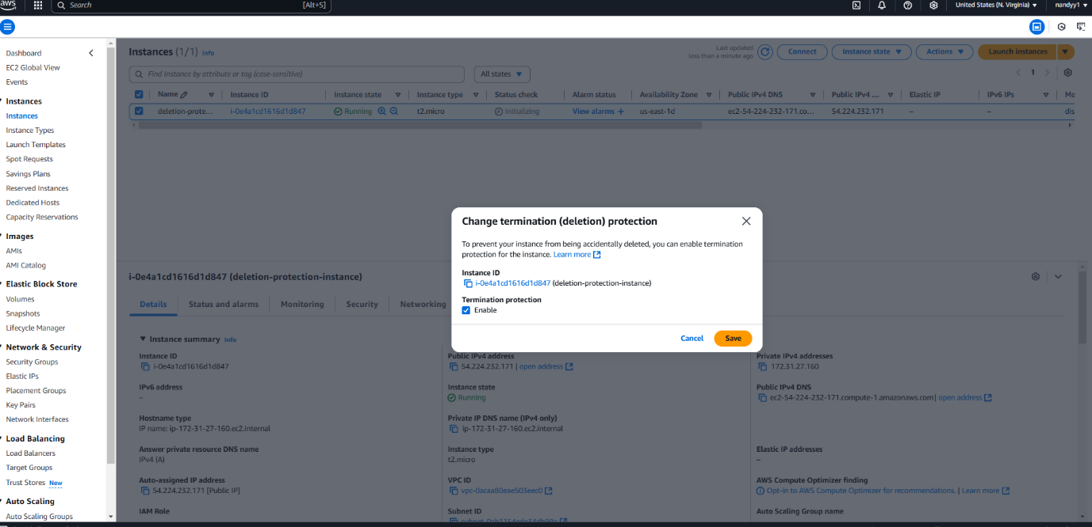

**Step 4**: If you try to terminate the instance the instance won’t get terminated because in the previous step we have enabled the prevent instance from being accidentally deleted.

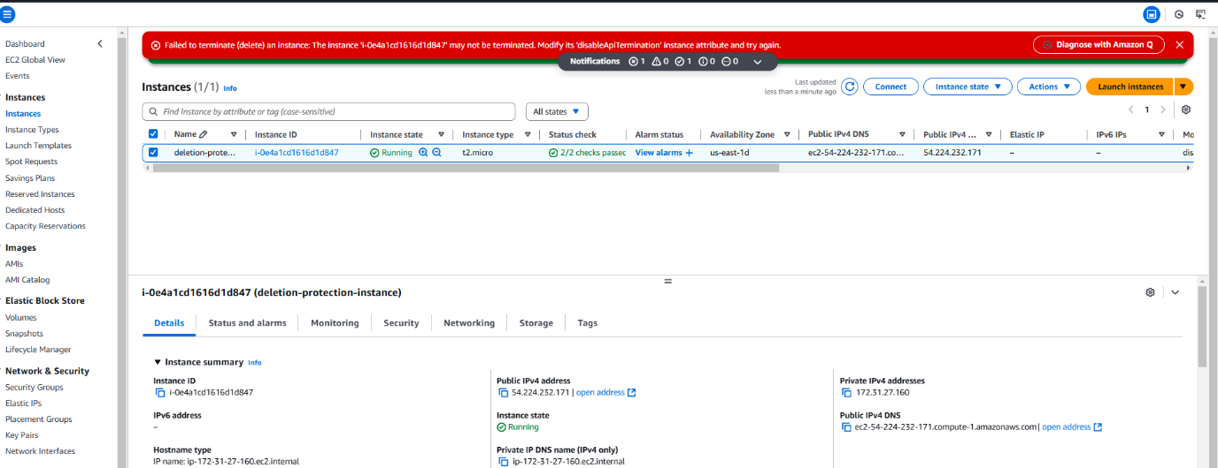

*This makes our instance to prevent from accidentally deletion process*

**Step 5**: To delete the instance navigate to the same setting where you enabled the button go and disable it for delete the instance.

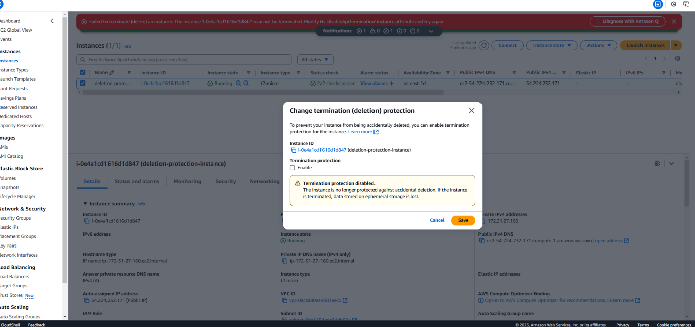

**Step 6**: Once it is disabled and save this settings now go to the instances and click on instance state and click terminate instance this will now get terminated.

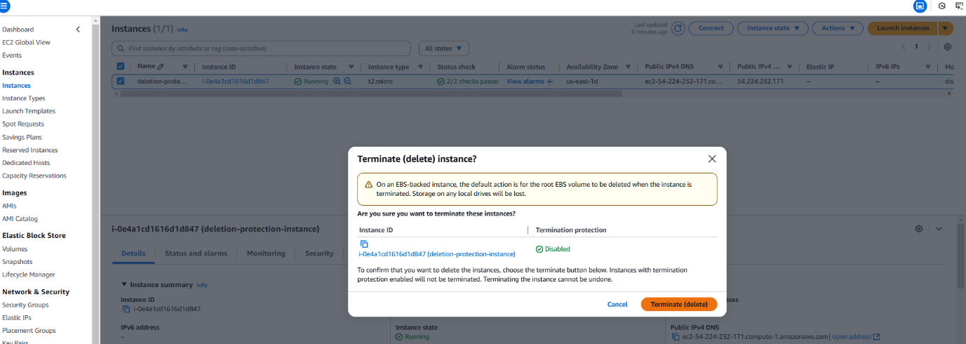

*The output is to enable accidental deletion instance and terminate the insatance*

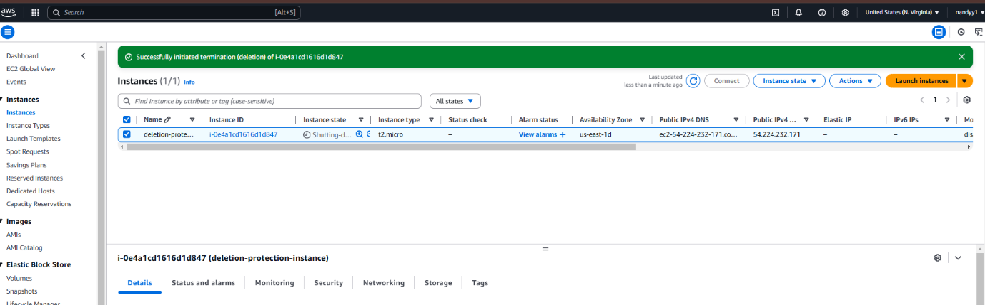

***Task 4 : Login the instance created by customized AMI***

Step-1: go to the aws instance settings and create an instance for custom AMI.

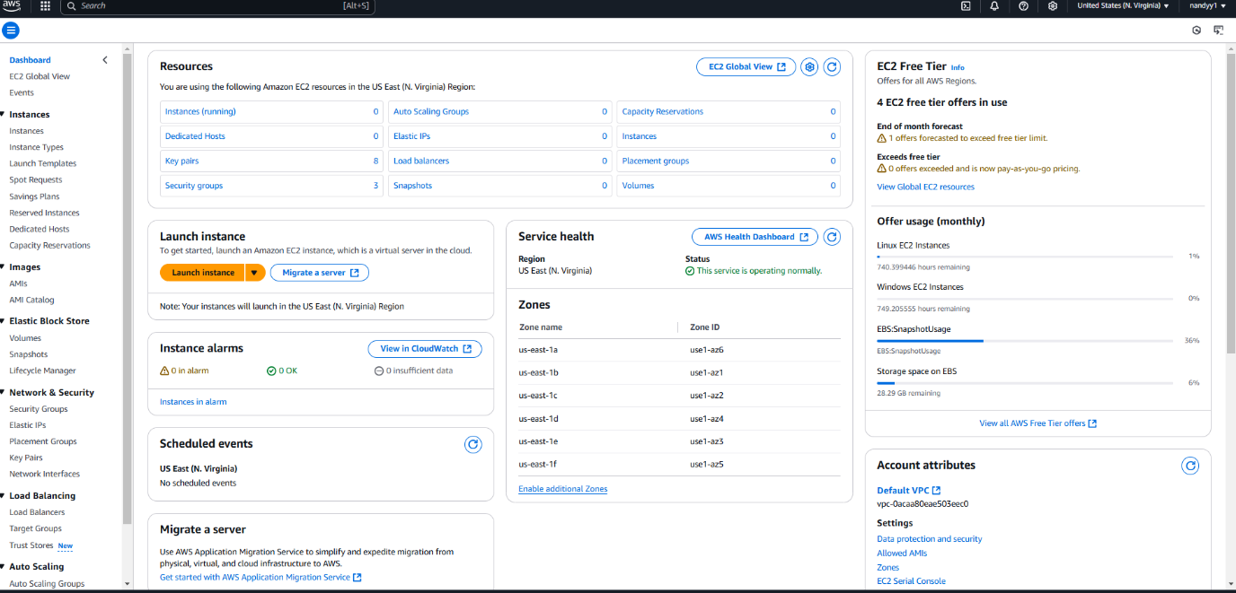

Click Launch instance

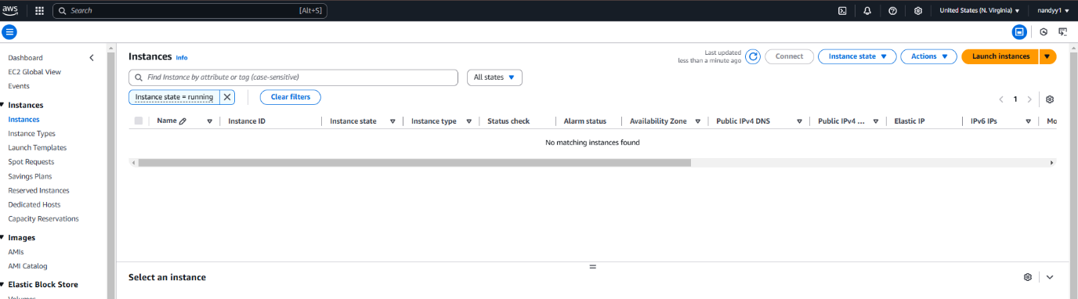

*After launching the instance will be available on the instances dashboard*

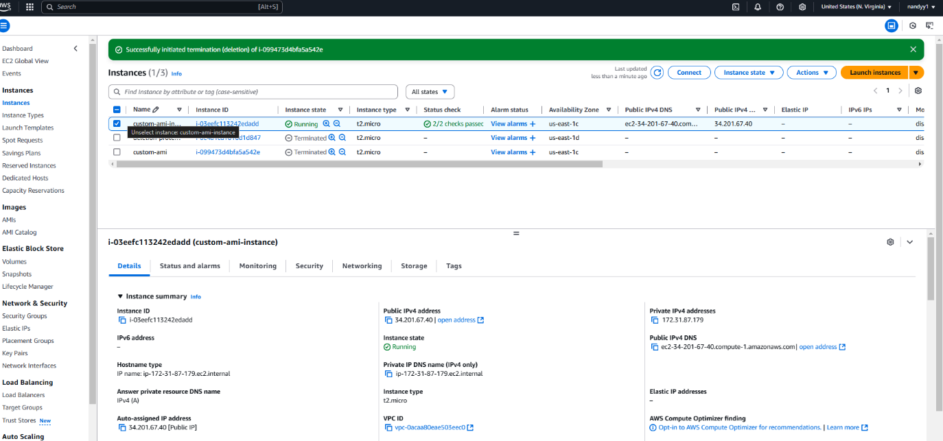

Step 2: Open Putty and load the PPK file and the CLI will open

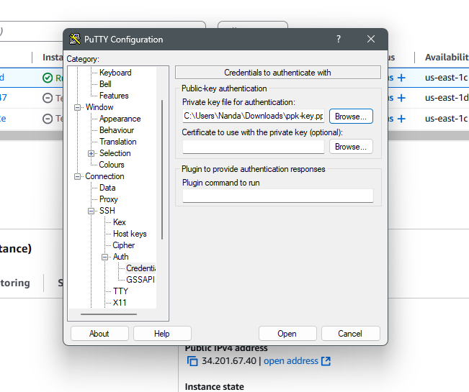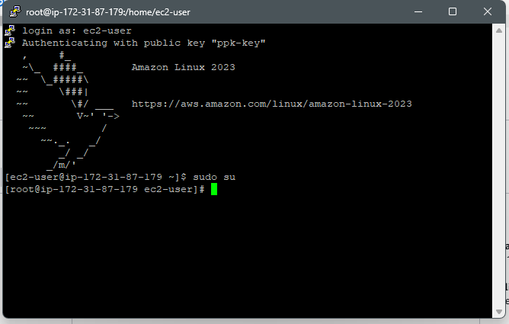

Step 3: Enter the commands to run the nginix server the nginix is the middleware server which is used to connect the physical system and the hardware.

This will be installed on the instances which we create.

Paste the Following commands

Sudo su

Yum update -y

Yum install nginx -y

systemctl start nginx

systemctl enable nginx

systemctl status nginix

Step-4: copy the instance IP and paste it on the web browser

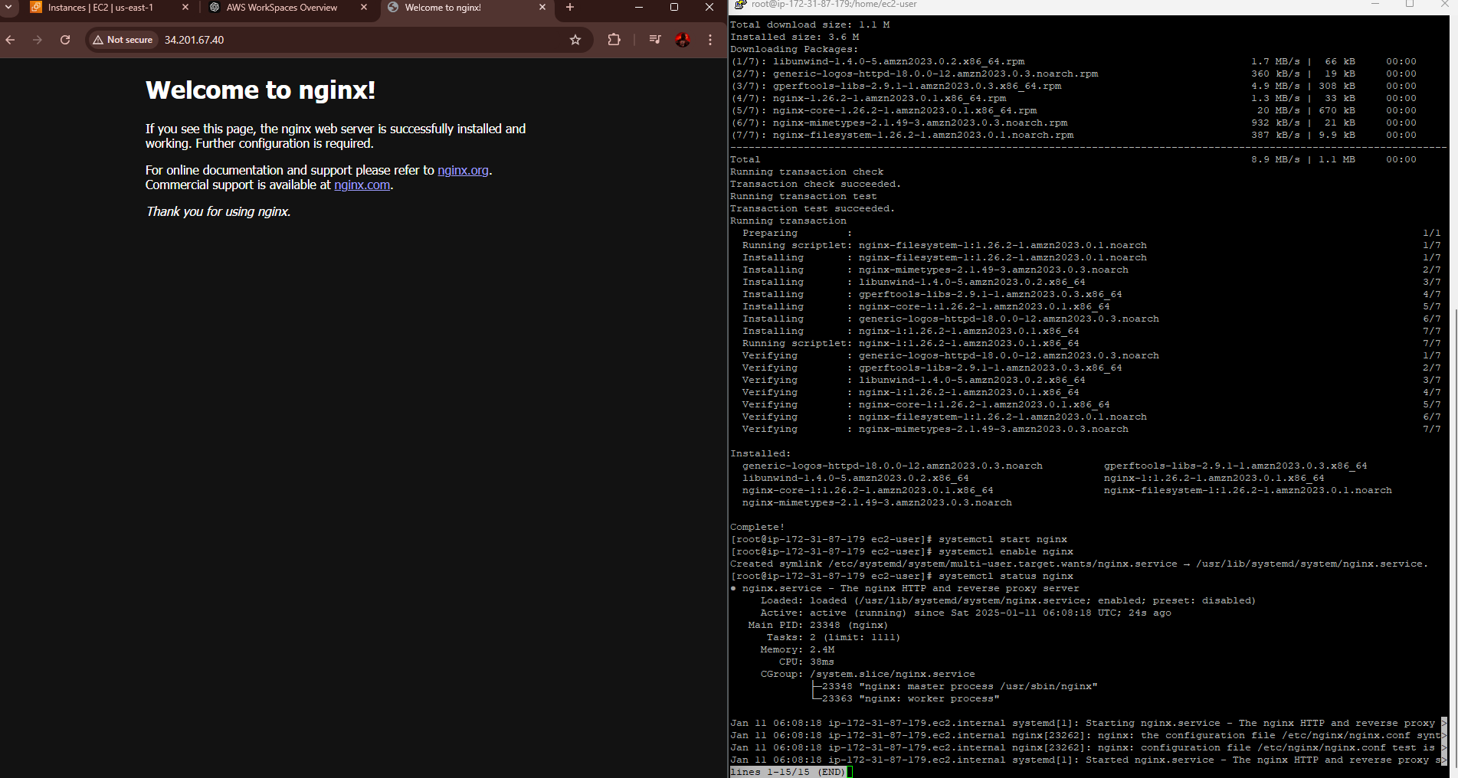

Step – 5 click the instance and click on actions -> image and templates -> create image for creating a custom ami.

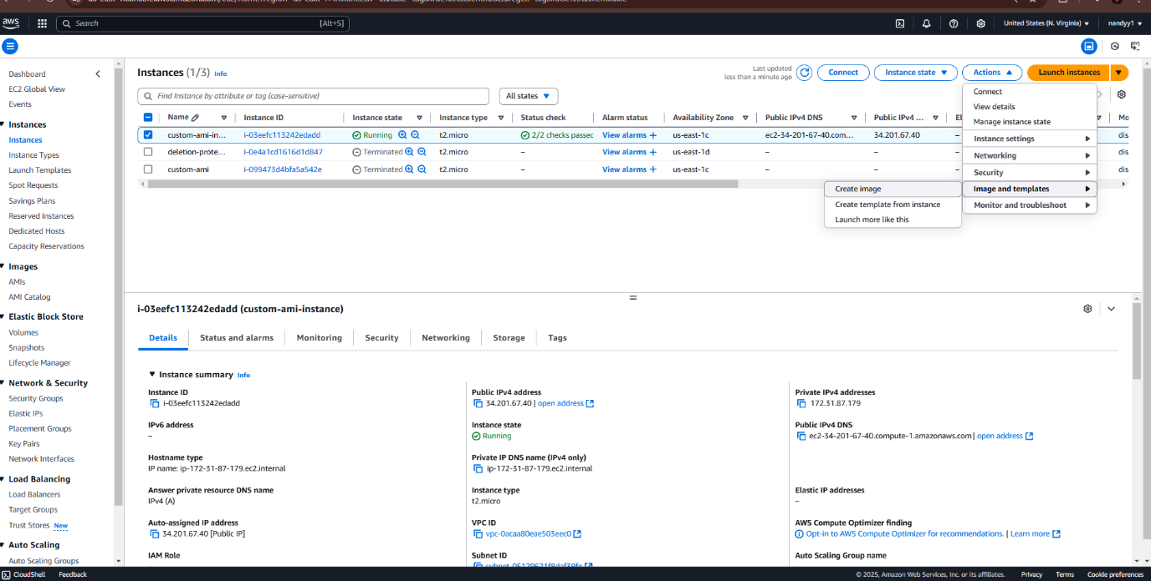

Create a custom AMI by selection following settings

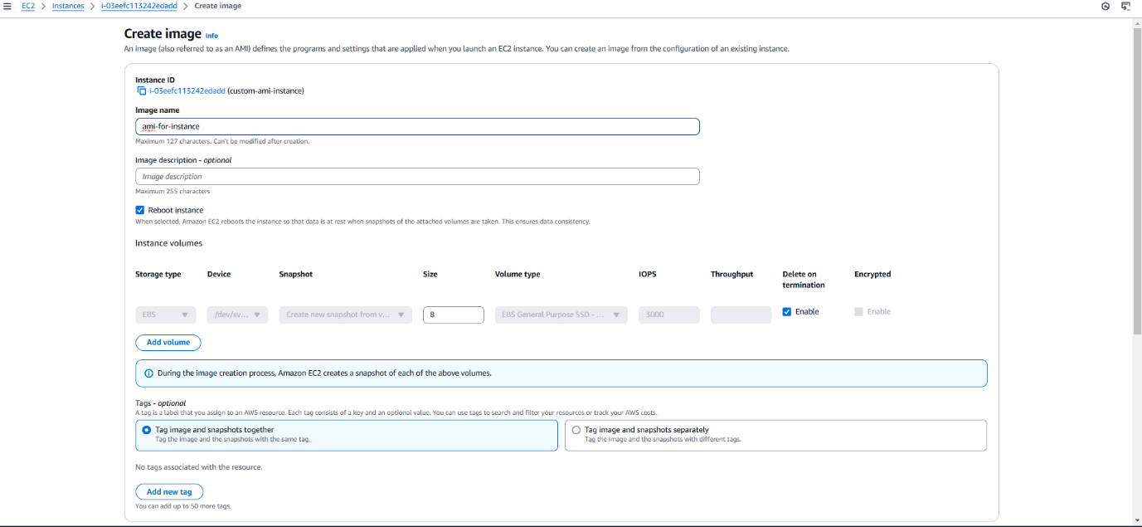

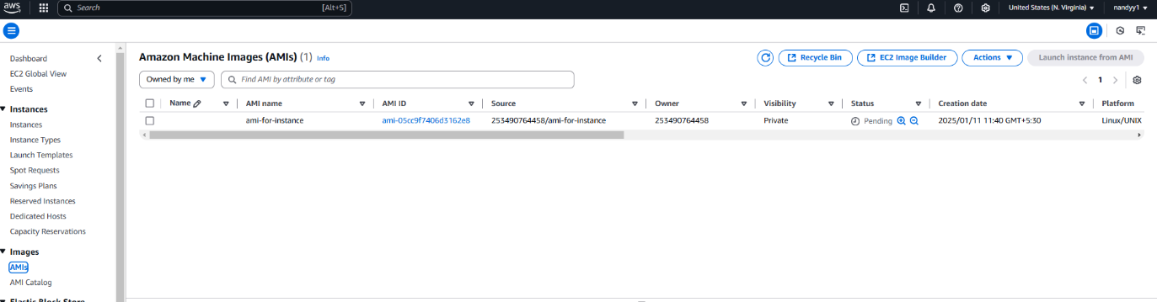

Step 6: Go to Ami and click Launch instance AMI and this is the Ami instance which you had created with the following configurations

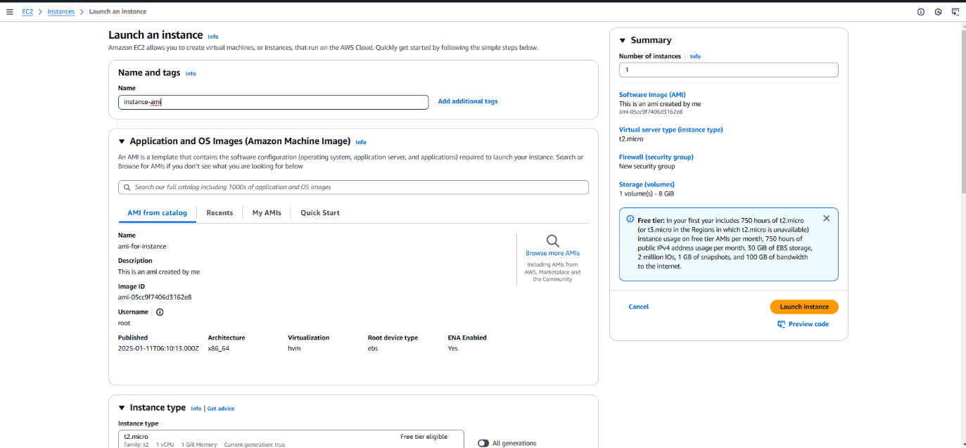

Now the instance and the instance with ami is running

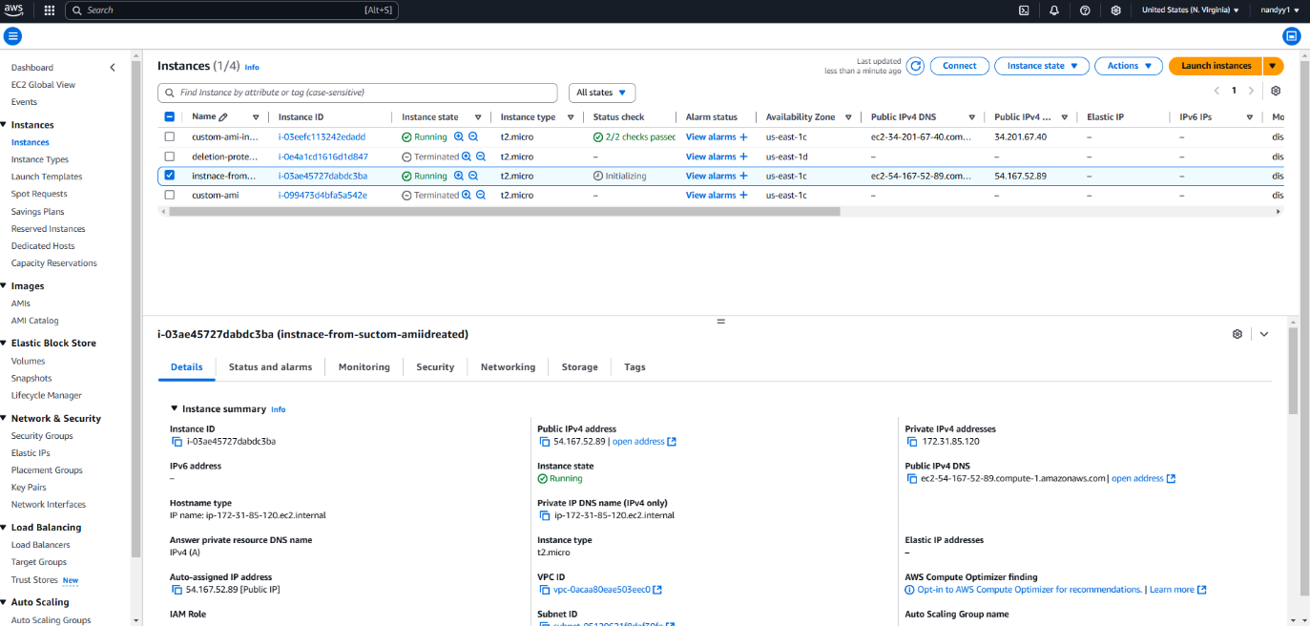

***Step -7***: Output for Login the instance created by customized AMI

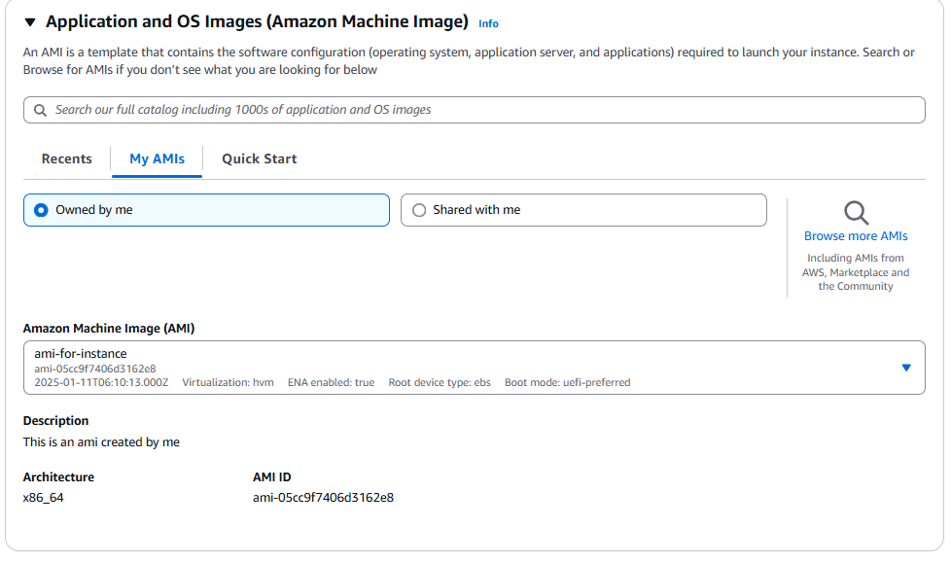

***Task-5 Transer volume to another region***

First creating the snapshot and creating the volume for the different availability zone

Step-1 : Create an instance

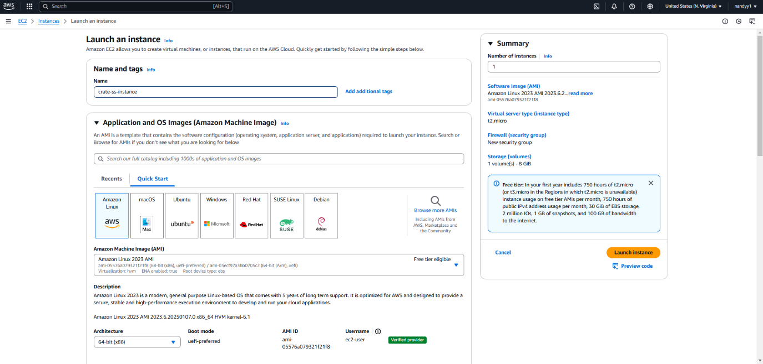

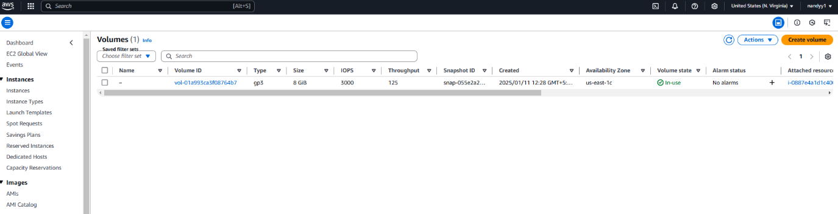

Step-2 : Go to volume and right click the volume and from the volume create a snapshot

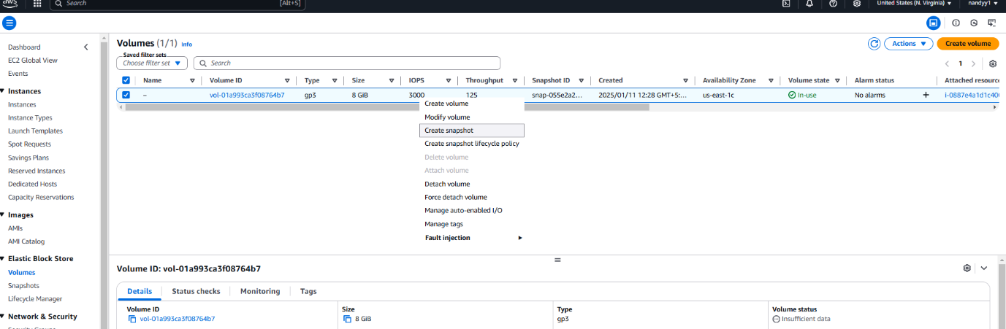

Snapshot is created

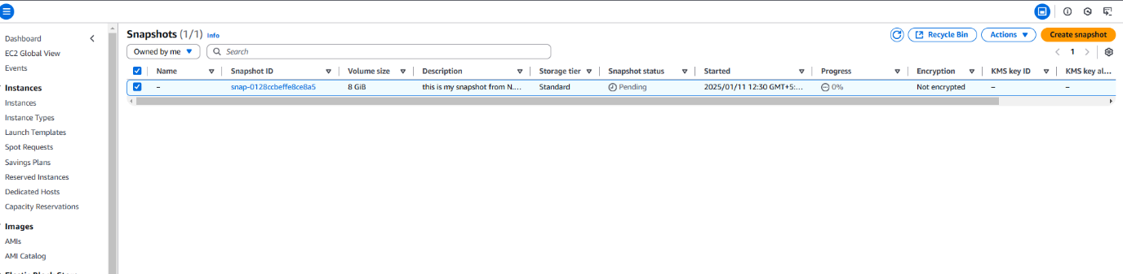

Step-3 : Click the snapshot and create the volume from the snapshot 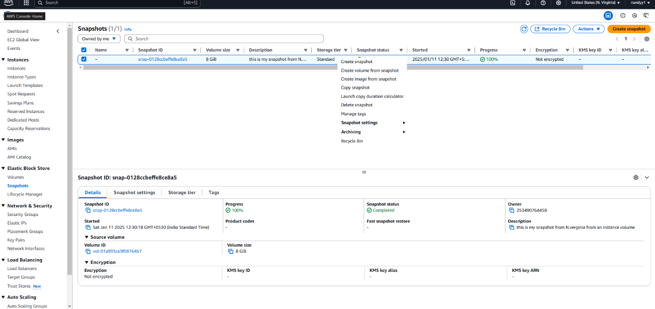

This volume can be encrypted and select the different available zone from the SAME region

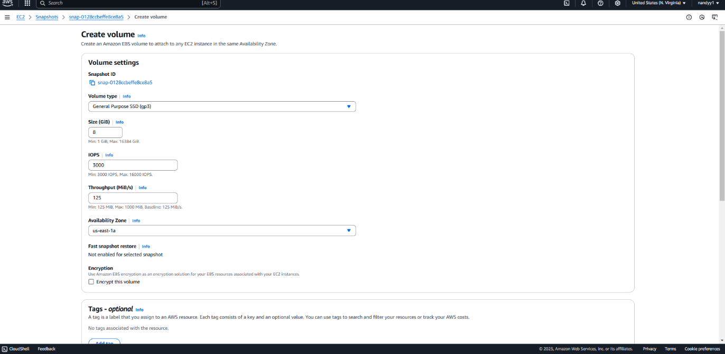

The first volume was us-east-1c and the volume created from the snapshot is us-east-1a

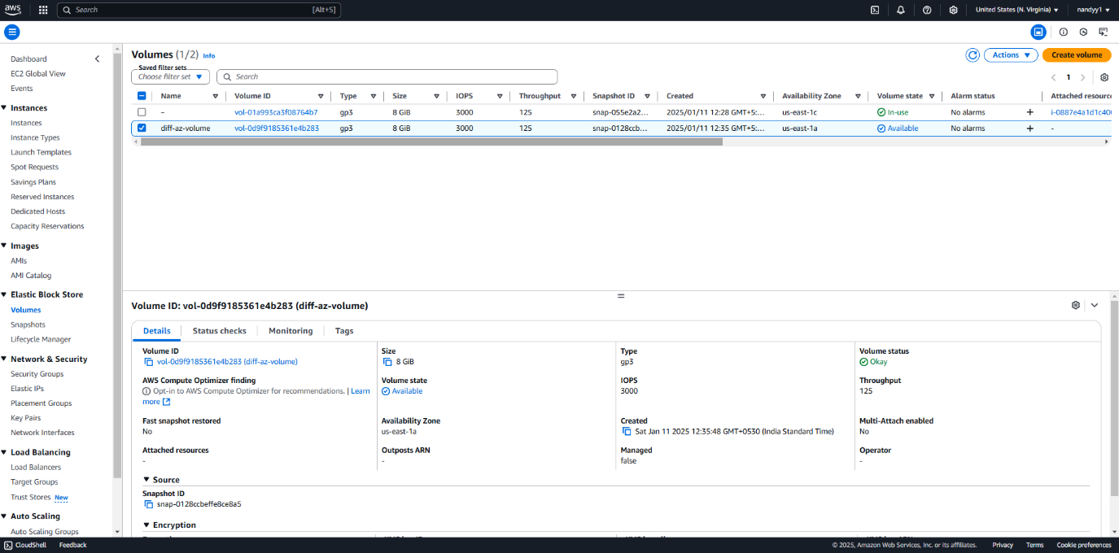

Step-4 : right click the snapshot -> copy -snapshot

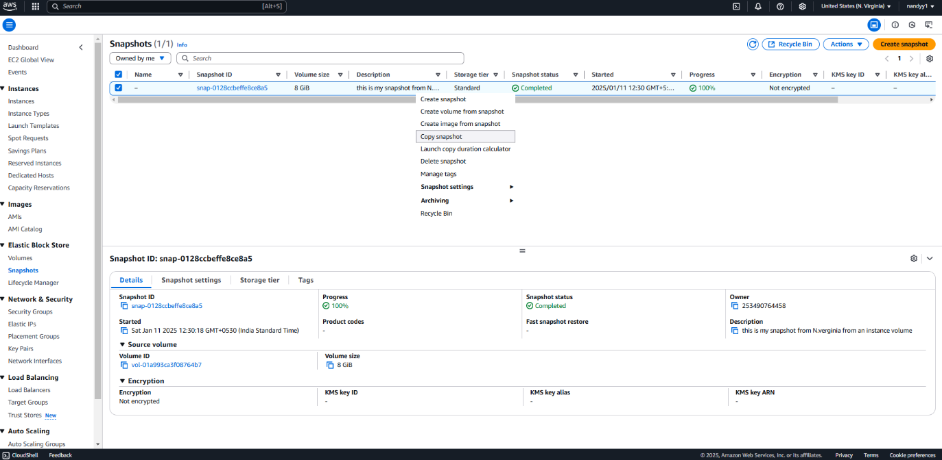

Copy snapshot to different region

Step-5: We can also proceeed with default settings and can also modify the setting for copying the snapshot for another region

* Encrypted
* Destination Region
* Tags

Then the new snapshot copy will be created for the new AZ’s

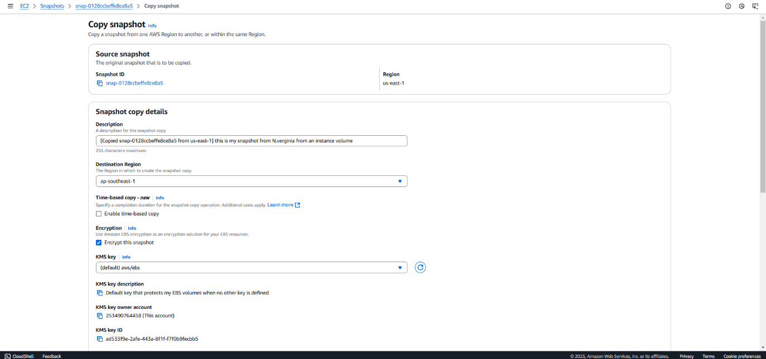

Step-6 : This is the Singapore region snapshot WHICH IS BIENG created

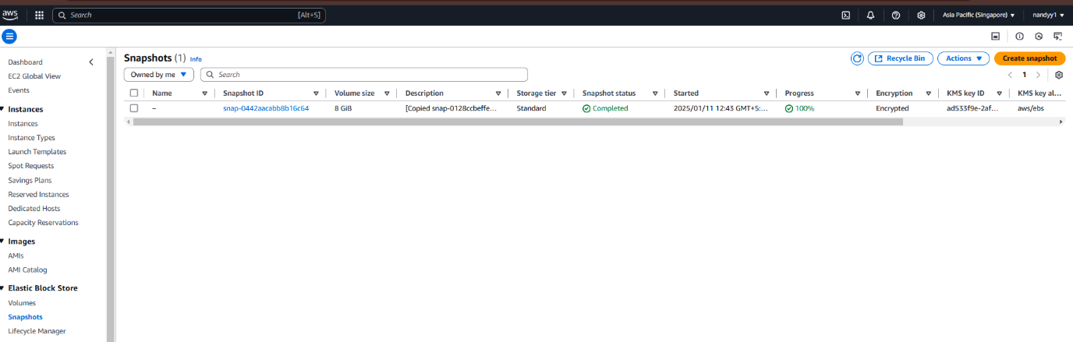

Step-7: create a volume for the snapshot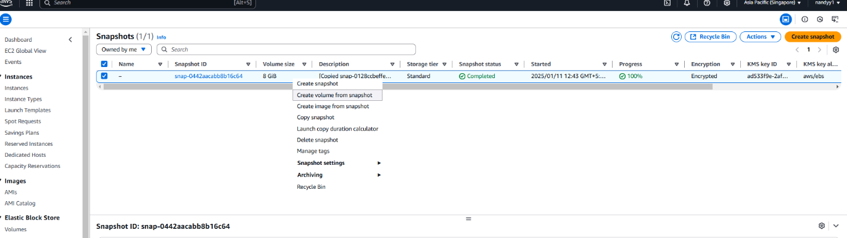

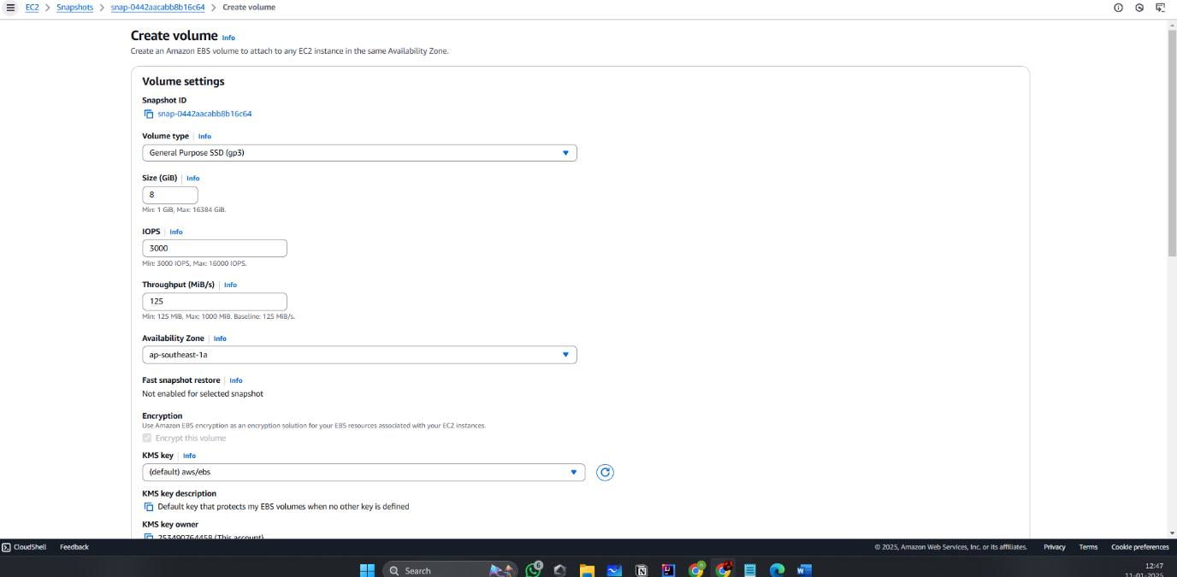

The output for task 5 is creating a snapshot to another region and availability zone and creating a volume from the snapshot

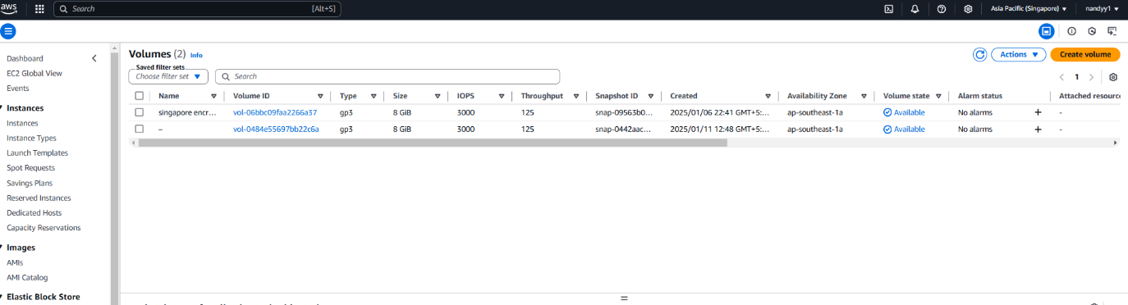

***Task-6 What is Placement group***

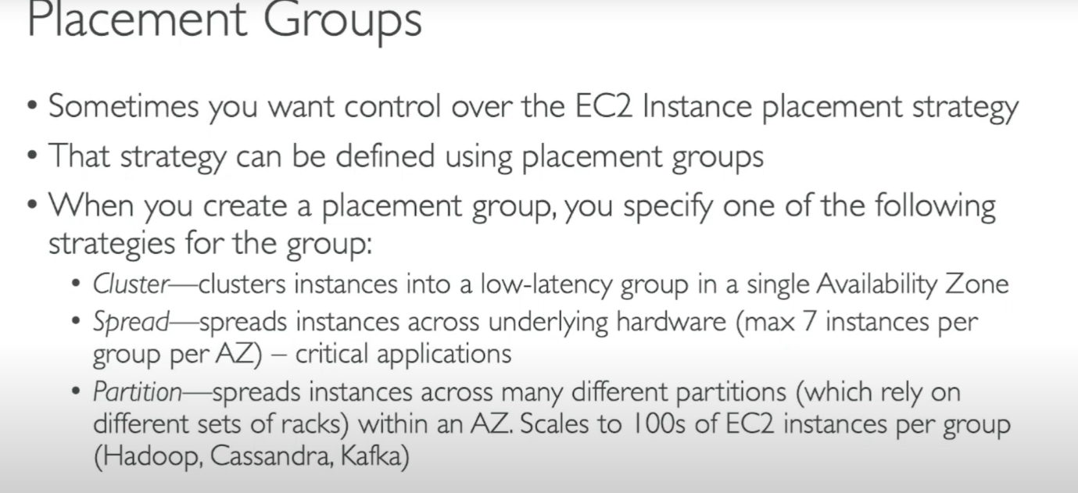

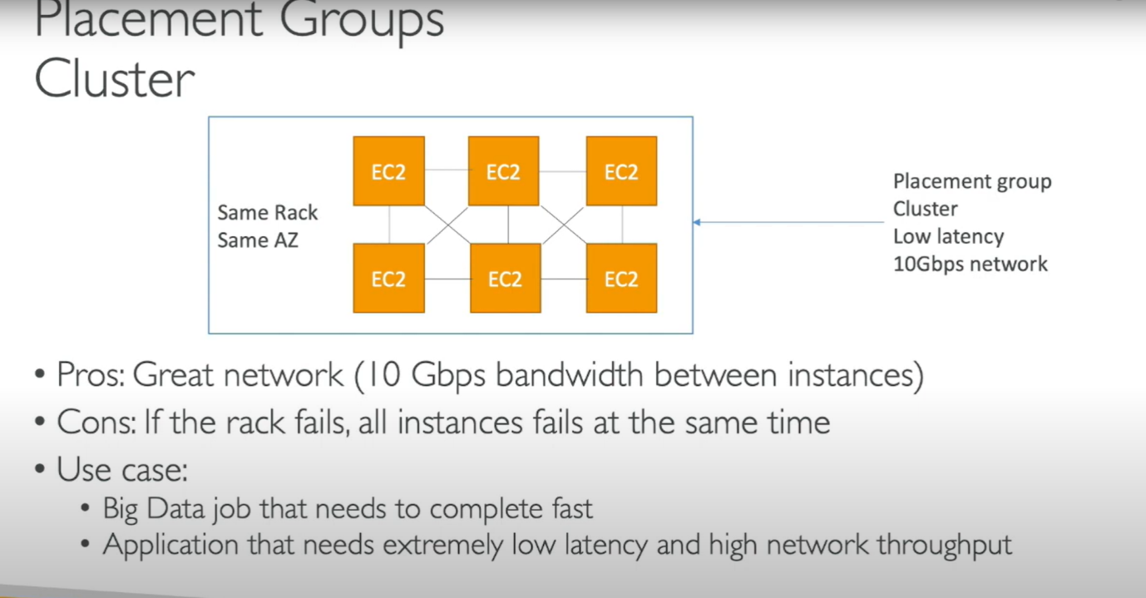

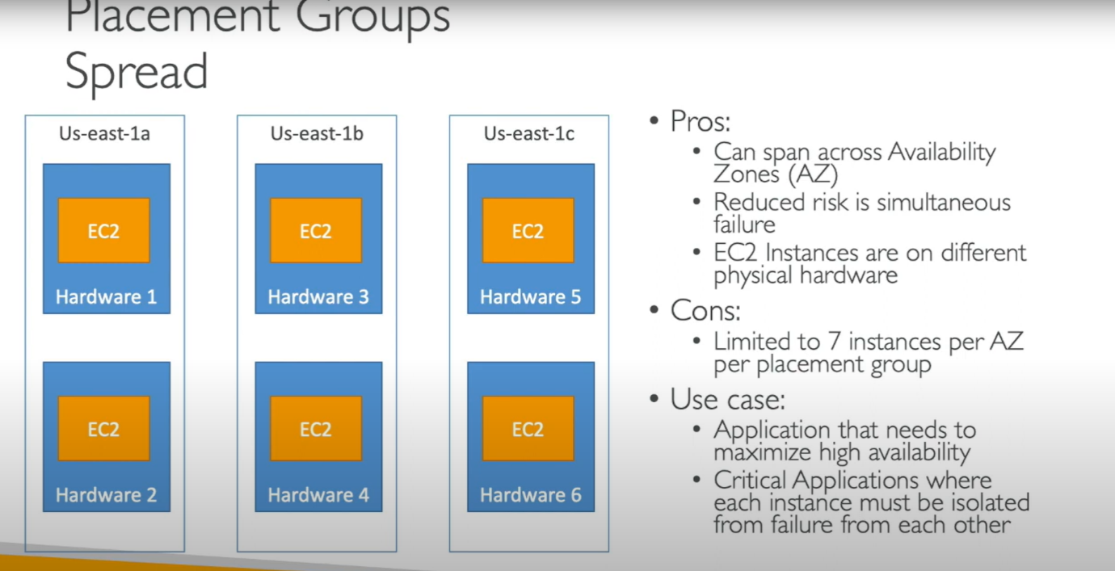

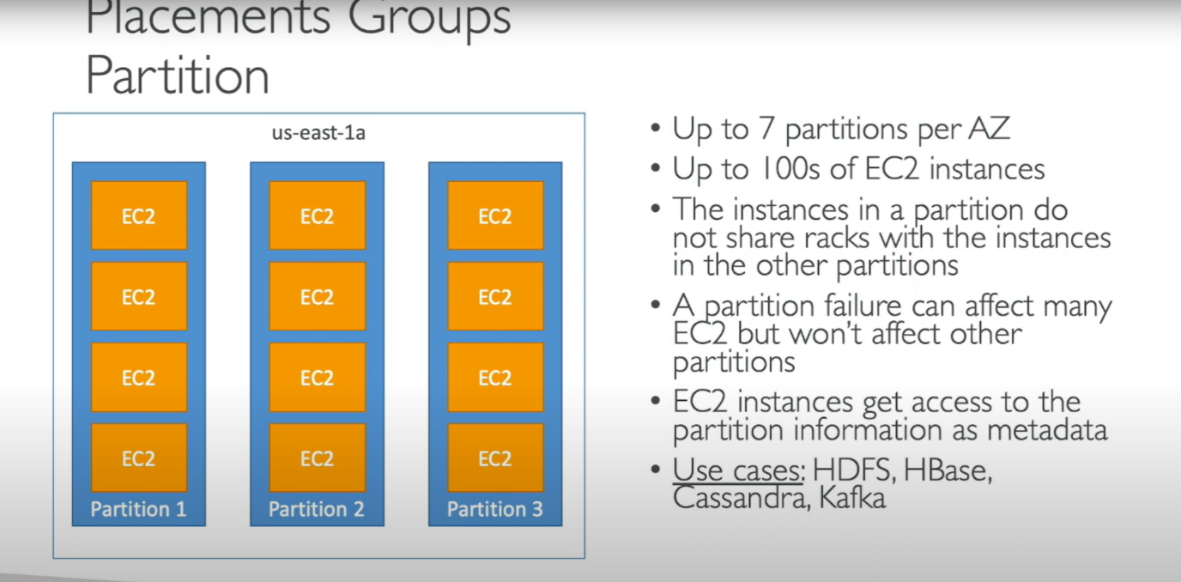

Step: 1 -> Go to the Aws console and go to Network & security under Placement Groups

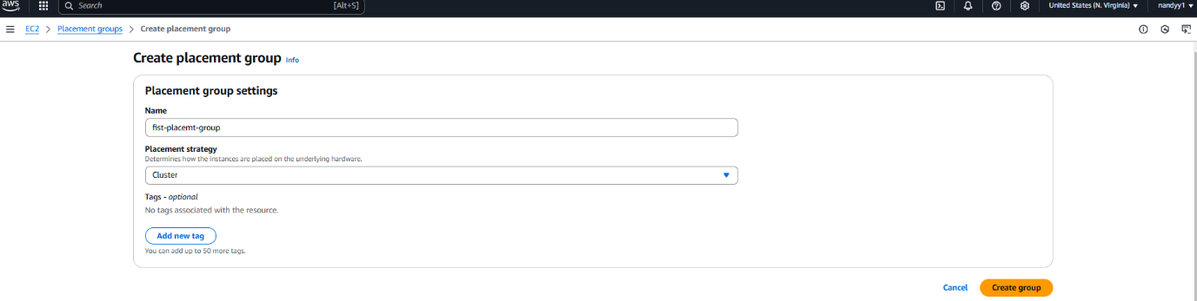

Step-2: Click create placement group and click cluster and name

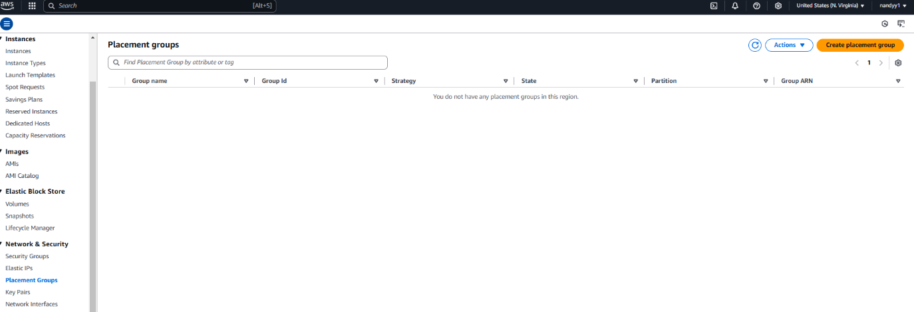

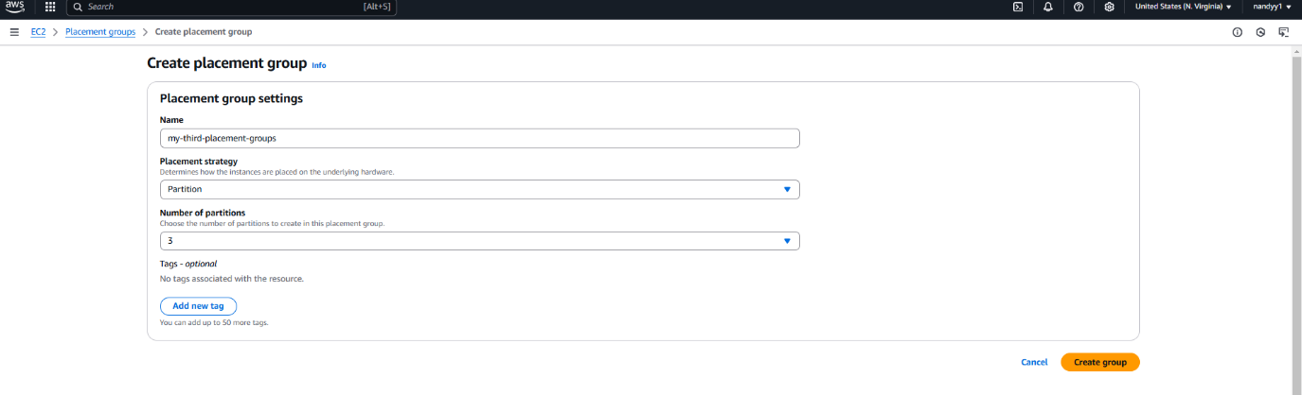

Step-3: after creating a cluster create a instance and attach the placement group under the advance settings

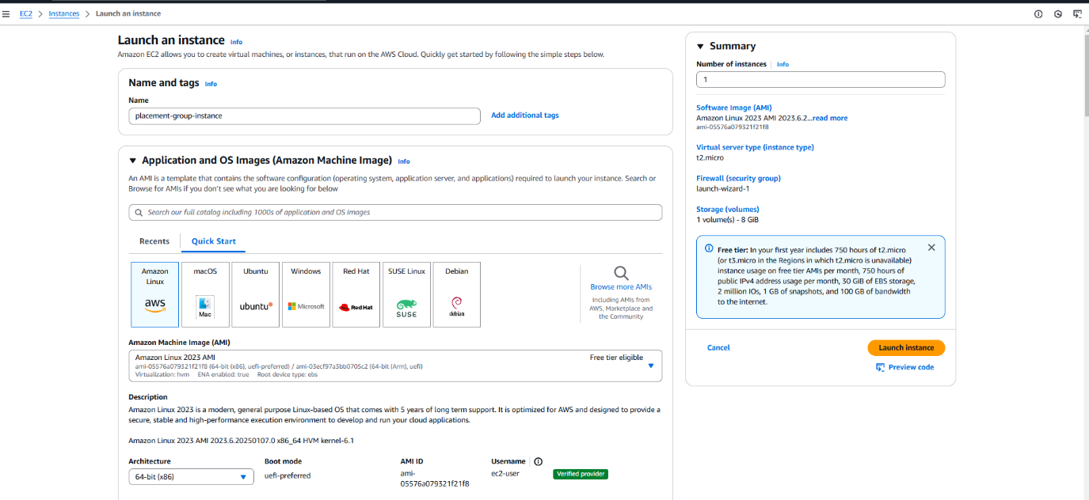

THis is the output of the following task 6. Placement groups

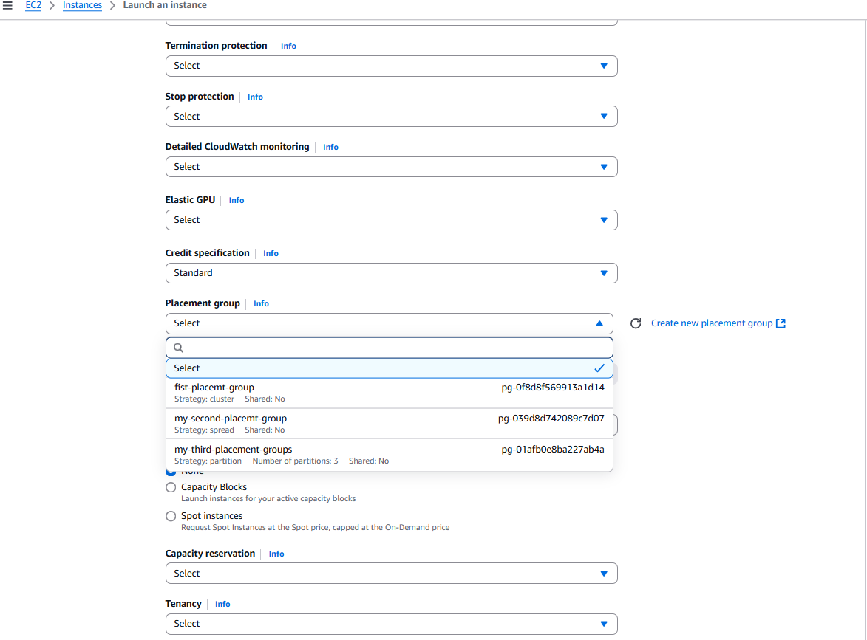

***Task-7: What are the different types of Instance types***

<https://aws.amazon.com/ec2/instance-types/> (Ref)

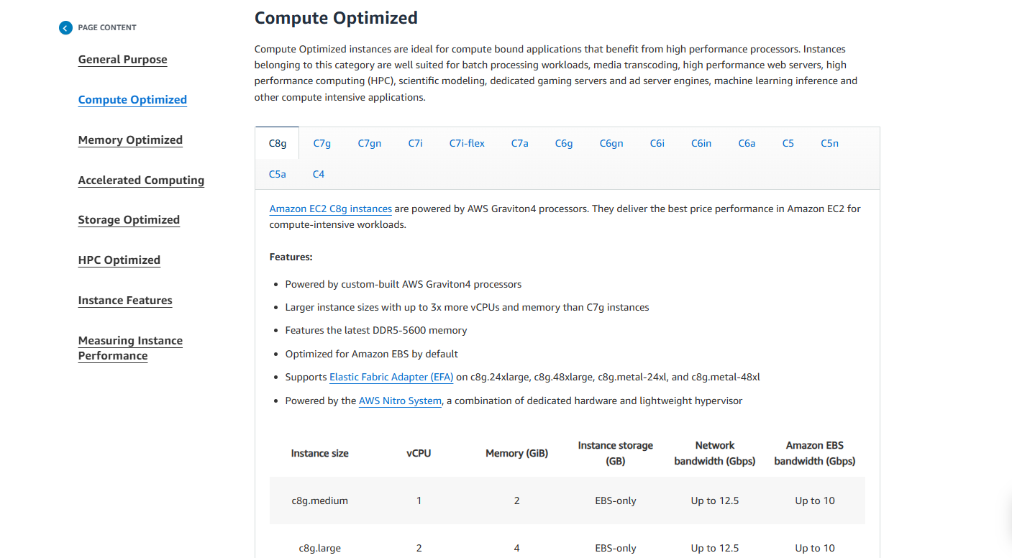

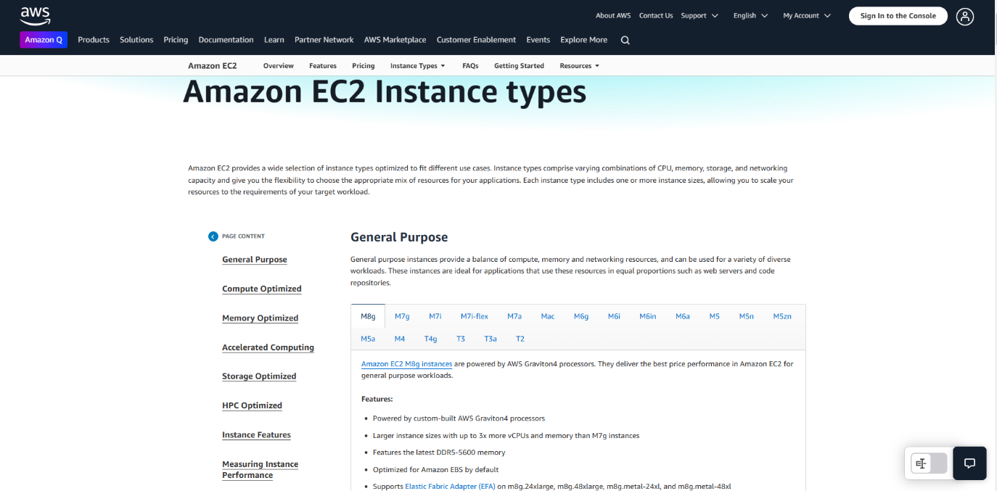

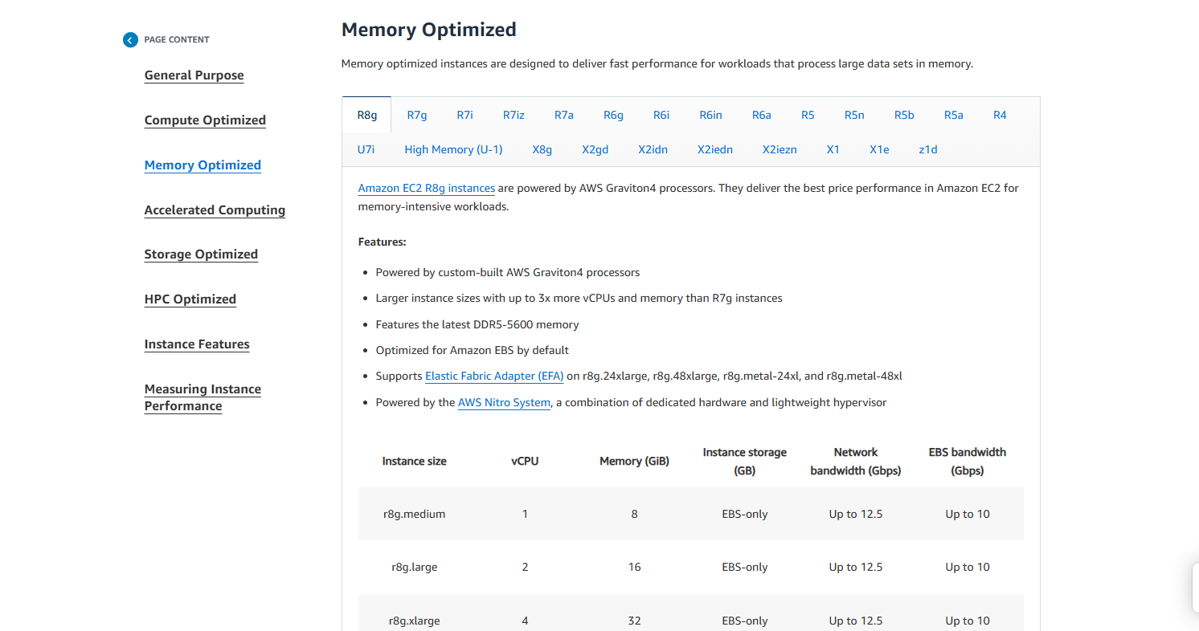

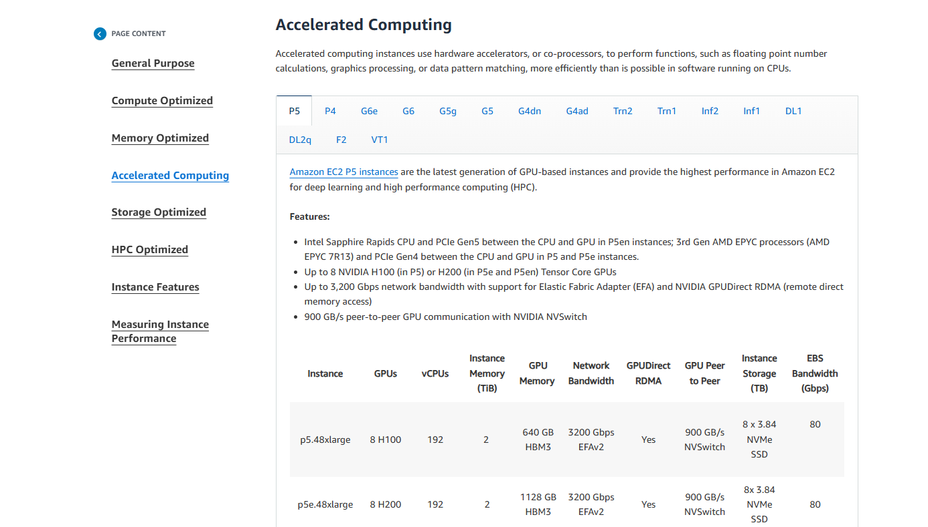

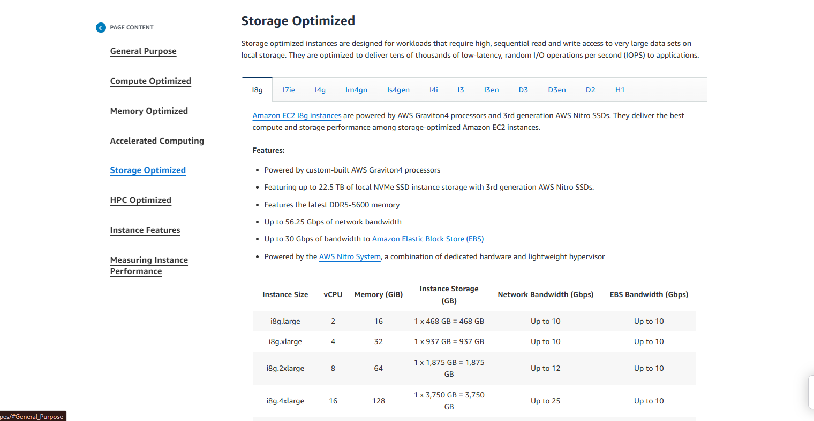

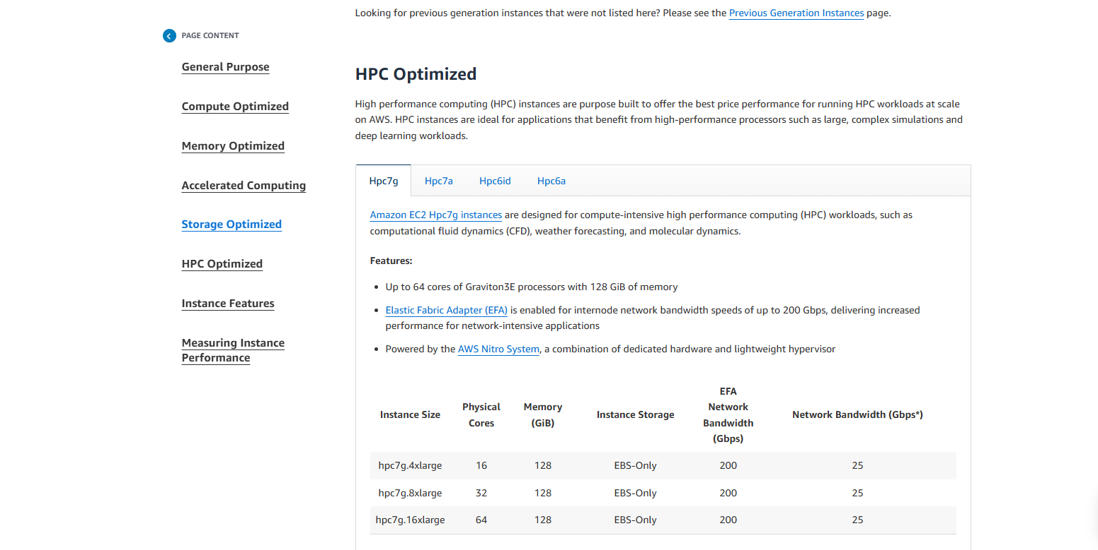

***Task-8 What is launch Template? Create one instance through Launch template***

It is a template which we can create and use like an ami, The AMI is created for the instnaces and the launch template is created for the whole Ec2 instance configuration which comes under every settings.

***Step1***: Click launch template and select the particulars which needed to be configured

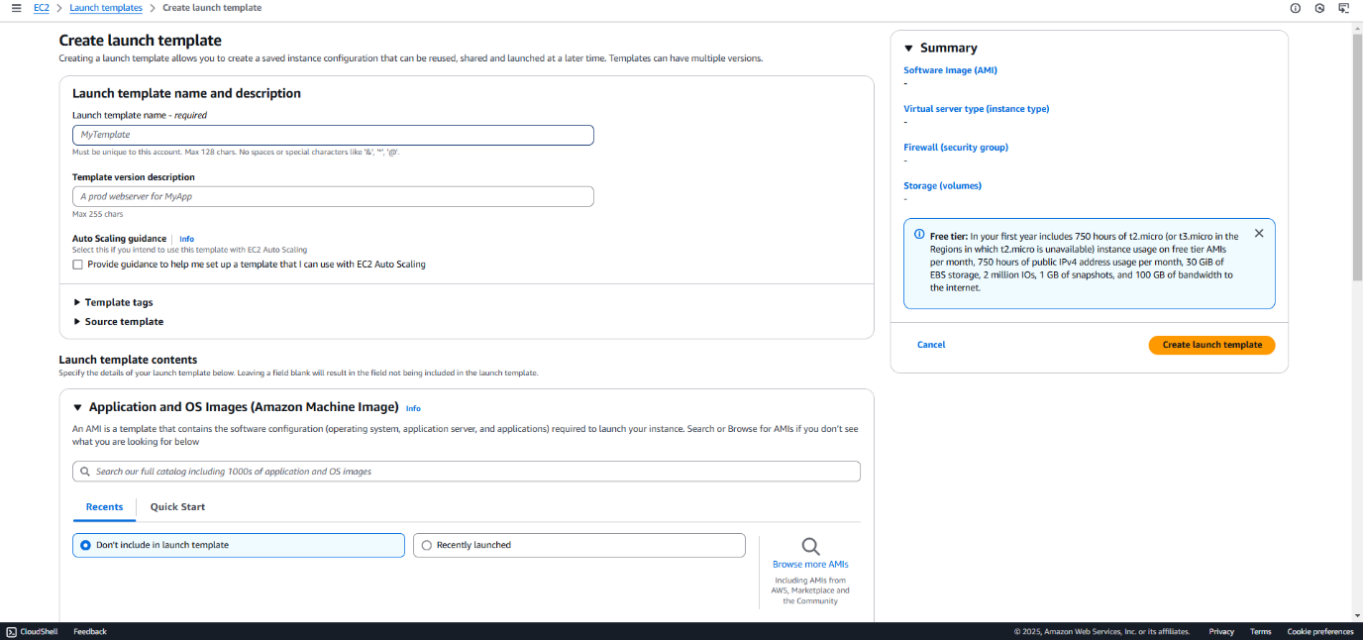

Once it is filled a summary will be shown on the right

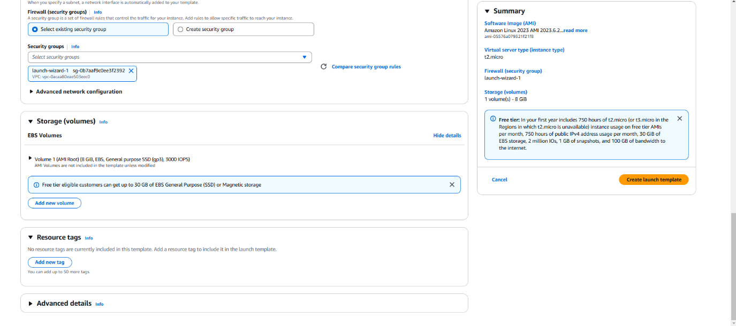

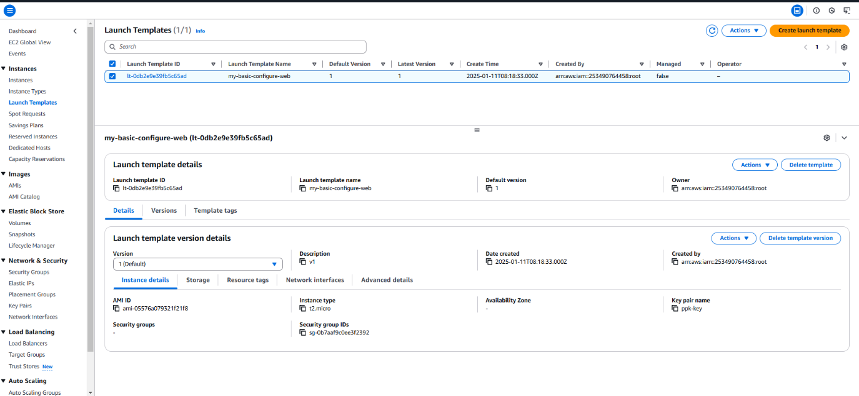

**Step 2** : click launch instance form the template

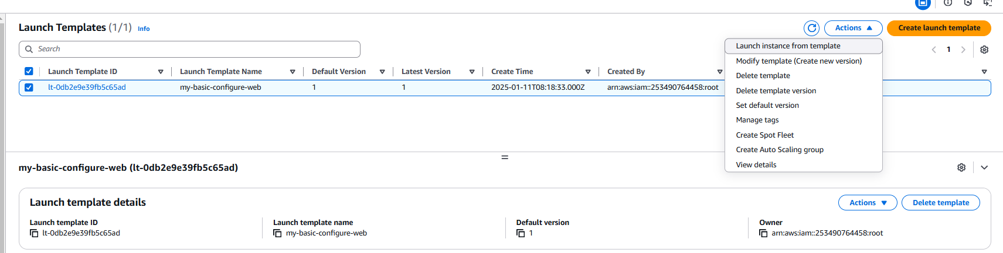

Select the instance name and check all the configurations are correct

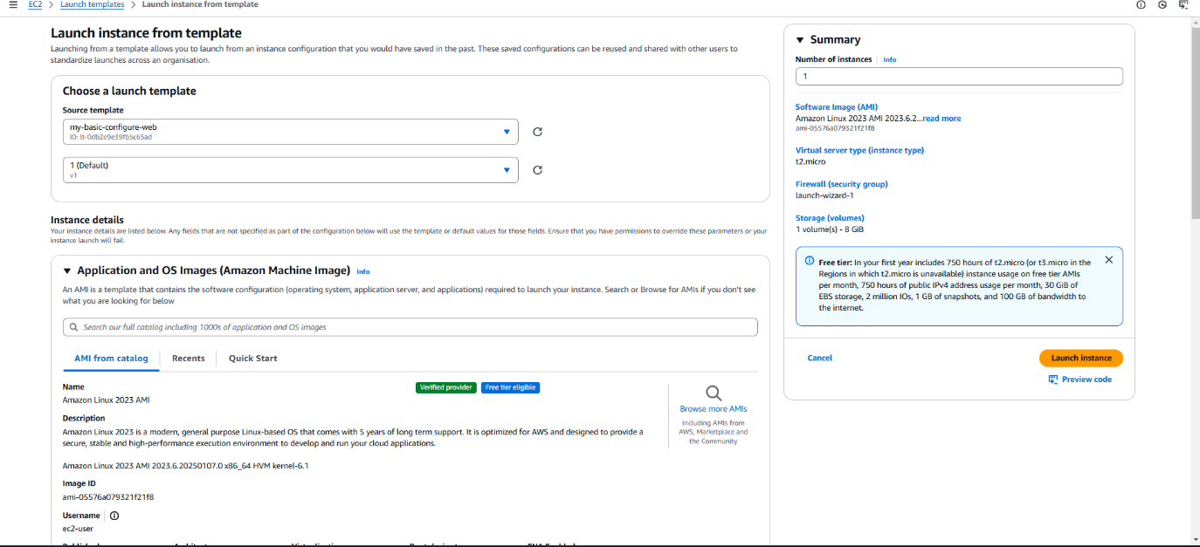

The output is Task 8 -> from the template an instance is being created

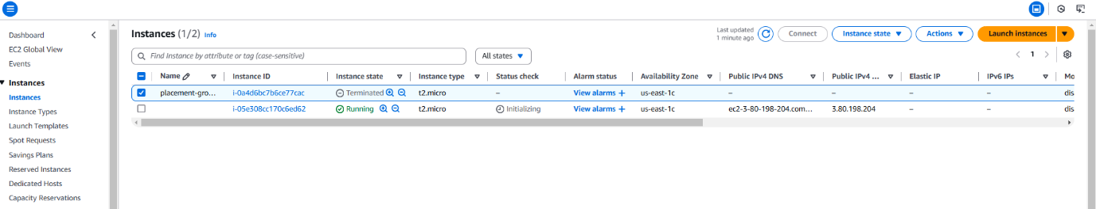

***Task-9 Describe about different volume types***

**1. General Purpose SSD (gp3 and gp2)**

**gp3 (Recommended)**

* **Use Case**: Most applications requiring high performance at low cost, including boot volumes, small databases, and development/test environments.
* **Performance**:
  + Baseline IOPS: 3,000 IOPS (default, scalable up to 16,000 IOPS).
  + Baseline Throughput: 125 MiB/s (scalable up to 1,000 MiB/s).
* **Cost Advantage**: Offers a lower price and more consistent performance compared to gp2.
* **IOPS Scaling**: Independent of volume size.

**gp2**

* **Use Case**: General-purpose workloads.
* **Performance**:
  + Baseline IOPS: 3 IOPS per GiB (minimum 100 IOPS, maximum 16,000 IOPS).
  + Burstable IOPS: Allows temporary performance bursts for smaller volumes.
* **IOPS Scaling**: Directly proportional to volume size.

**2. Provisioned IOPS SSD (io1 and io2)**

**io2 (Recommended for High Durability)**

* **Use Case**: Critical applications requiring sustained high performance, low latency, and high durability (e.g., large databases like Oracle, Microsoft SQL Server).
* **Performance**:
  + Up to 64,000 IOPS.
  + Durability: 99.999% (higher than io1).
  + Supports Multi-Attach (attach to multiple EC2 instances).
* **Cost**: Higher than gp3/gp2.

**io1**

* **Use Case**: High-performance workloads with lower durability needs than io2.
* **Performance**:
  + Up to 64,000 IOPS.
  + Durability: 99.8%-99.9%.
* **Cost**: Slightly less than io2 but less durable.

**3. Throughput Optimized HDD (st1)**

* **Use Case**: Streaming workloads requiring high throughput, such as big data, data warehouses, and log processing.
* **Performance**:
  + Sequential Throughput: Up to 500 MiB/s.
  + Baseline Performance: 40 MB/s per TiB.
  + IOPS: Not suitable for small or random I/O operations.
* **Cost**: Lower than SSD volumes.

**4. Cold HDD (sc1)**

* **Use Case**: Infrequently accessed data, such as cold storage and archival backups.
* **Performance**:
  + Sequential Throughput: Up to 250 MiB/s.
  + Baseline Performance: 12 MB/s per TiB.
  + IOPS: Not suitable for small or random I/O operations.
* **Cost**: Lowest among all EBS volume types.

**5. Magnetic (Standard) [Deprecated]**

* **Use Case**: Legacy workloads with low performance requirements.
* **Performance**: Lower IOPS and throughput compared to modern volumes.
* **Cost**: Cheaper than SSDs but rarely used due to the availability of better options.

**Comparison Table**

| **Volume Type** | **Max IOPS** | **Max Throughput** | **Use Case** | **Cost** |
| --- | --- | --- | --- | --- |
| **gp3** | 16,000 | 1,000 MiB/s | General workloads, boot volumes | $$ |
| **gp2** | 16,000 | 250 MiB/s | General workloads | $$ |
| **io2** | 64,000 | 1,000 MiB/s | Critical apps, large databases | $$$$ |
| **io1** | 64,000 | 1,000 MiB/s | High-performance workloads | $$$ |
| **st1** | N/A | 500 MiB/s | Streaming, big data, log processing | $ |
| **sc1** | N/A | 250 MiB/s | Archival, infrequently accessed workloads | $ |

**Choosing the Right Volume Type (Industry Examples)**

* **Web Server Hosting (gp3)**: A general-purpose SSD provides low latency and high performance for serving website traffic.
* **E-commerce Databases (io2)**: Critical, low-latency applications need io2 for consistent performance and durability.
* **Big Data Analytics (st1)**: For high throughput during log analysis or data streaming.
* **Backup Storage (sc1)**: Cold HDDs for storing archival data at minimal cost.

Let me know if you need more clarity or assistance setting up any of these volume types!

***Task 10: Give region based access to IAM user***

Step1: Create an Ec2 instance

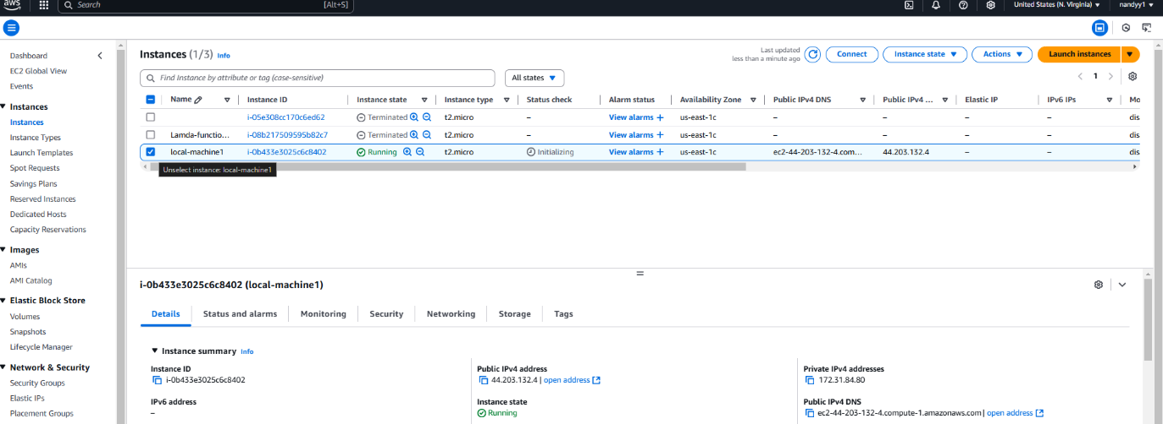

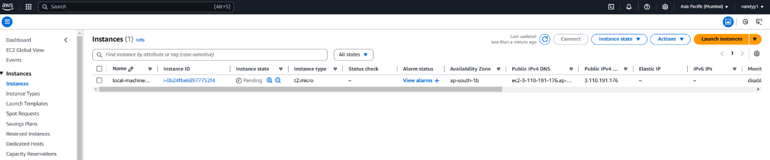

Step2: create an Iam user

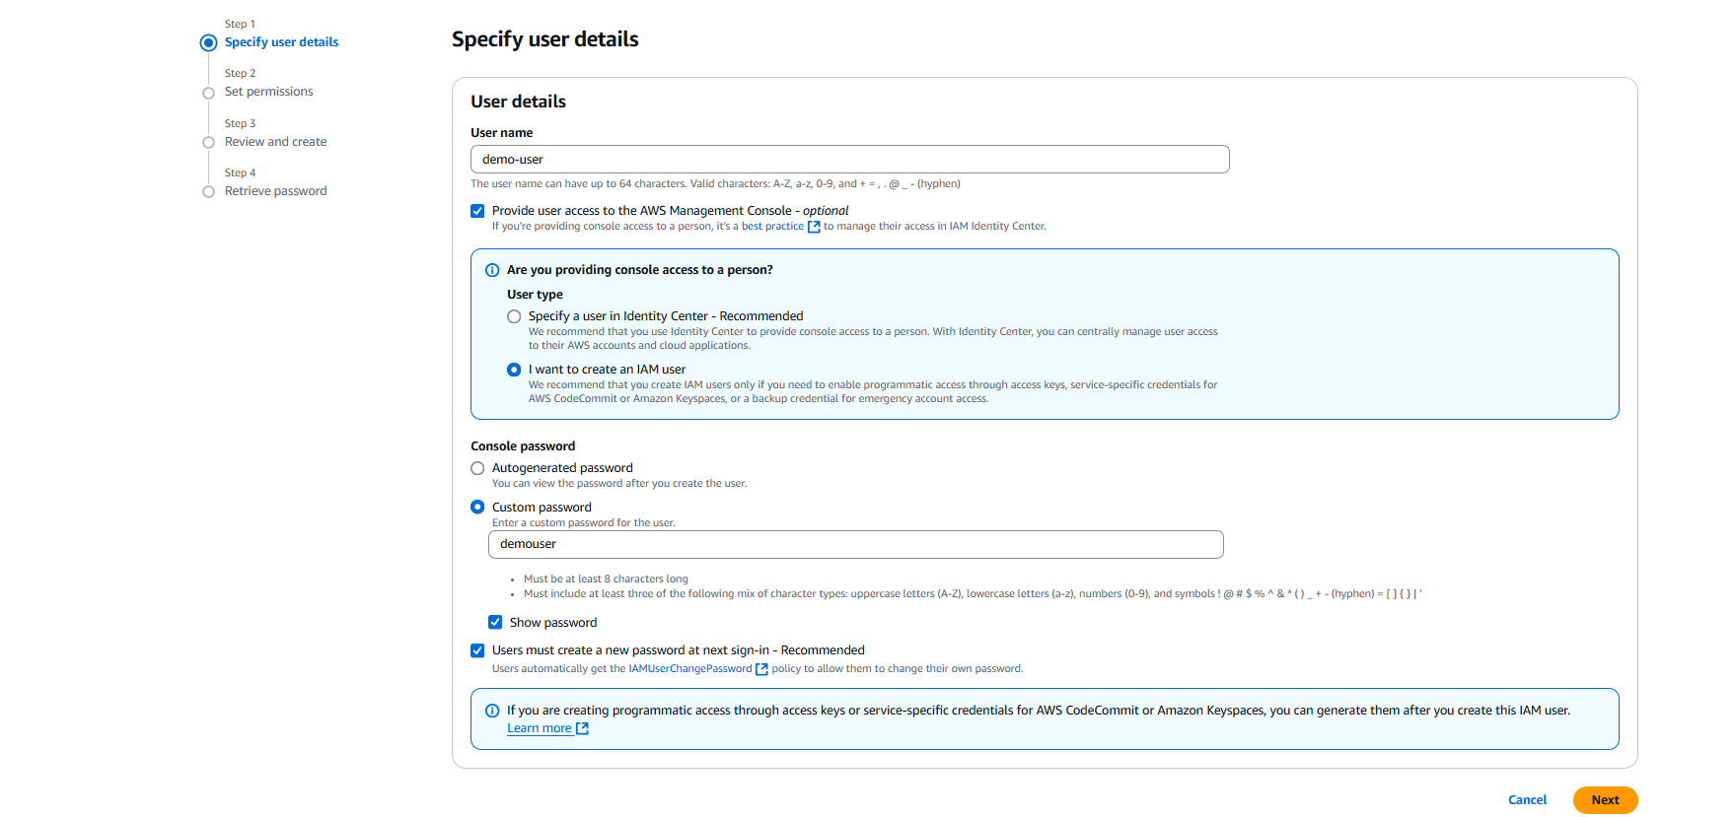

Step 4: go to the iam browswer and see if any instance running user api fetch error

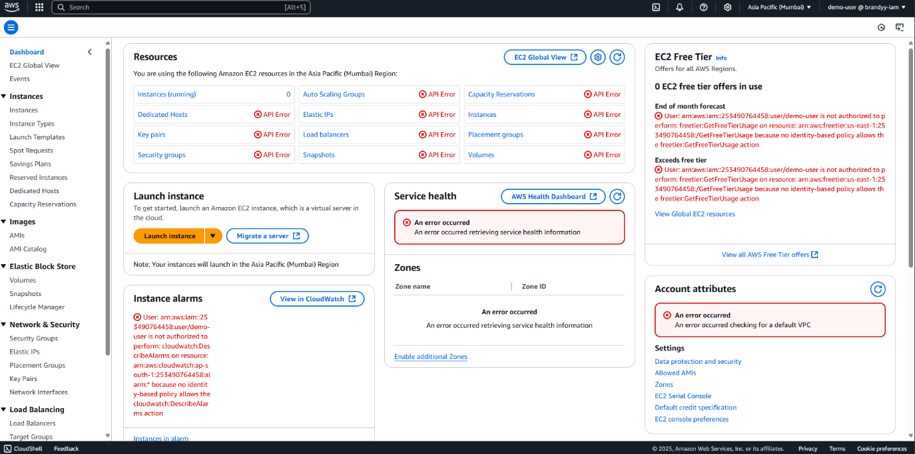

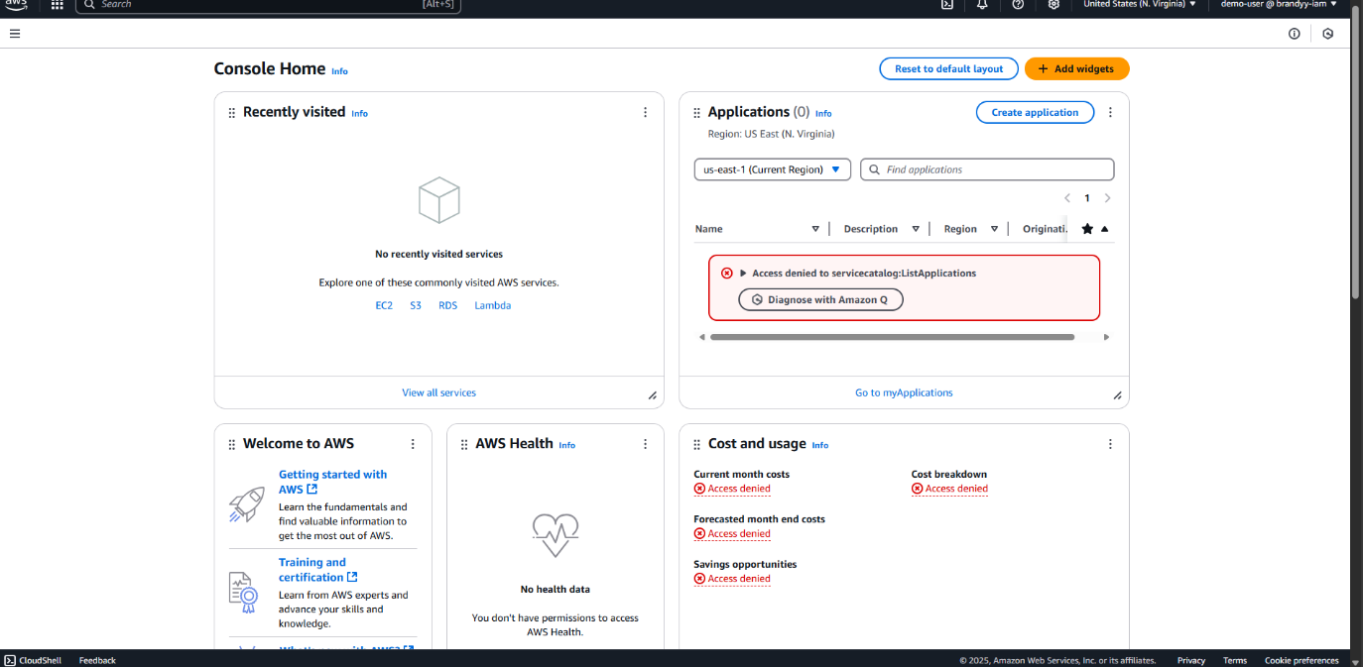

Step 5 : Create a policy for the user

\

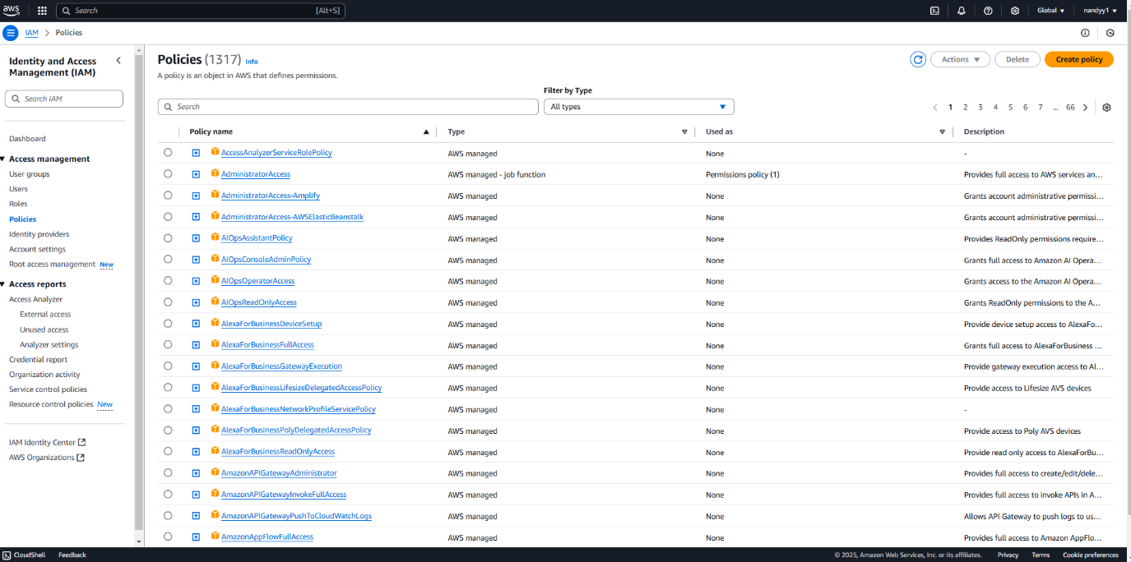

Step 6: In the request condition section click add another condition

Search ec2:Region

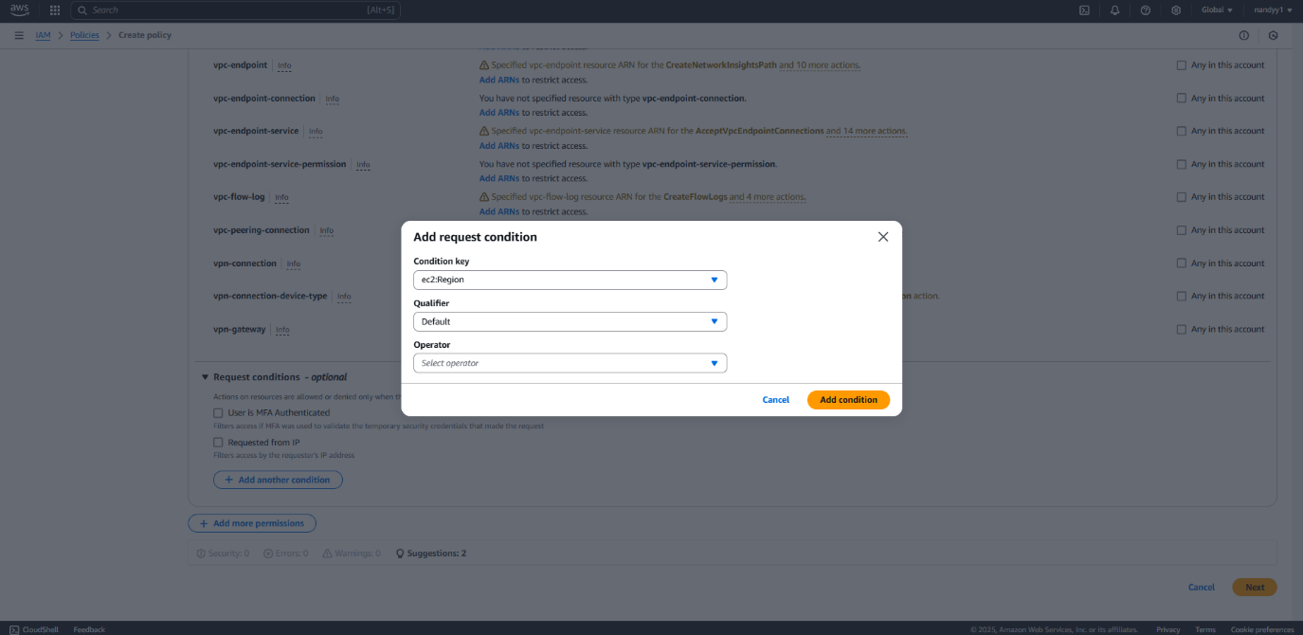

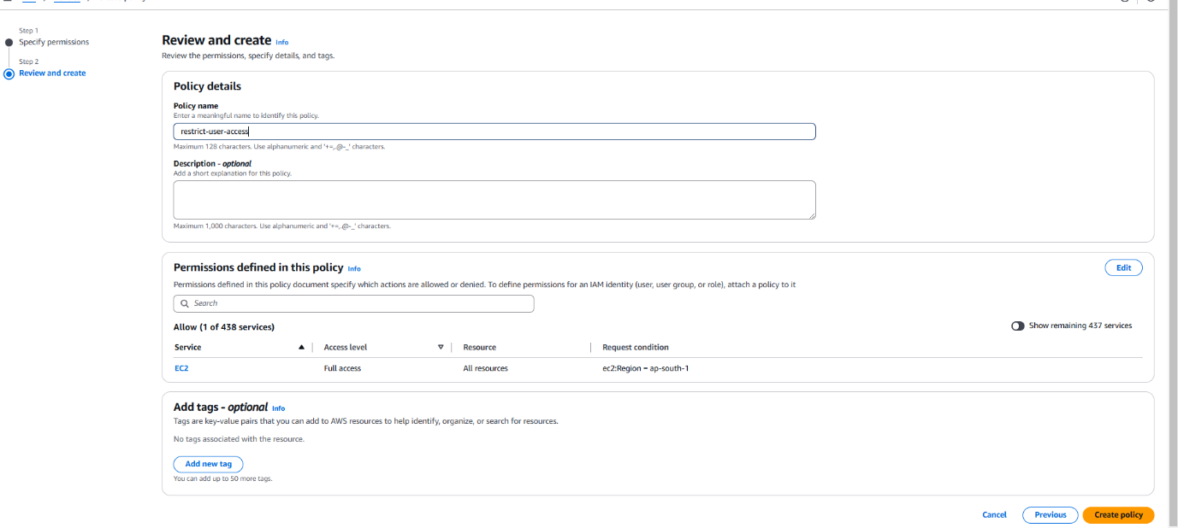

Policy had been created

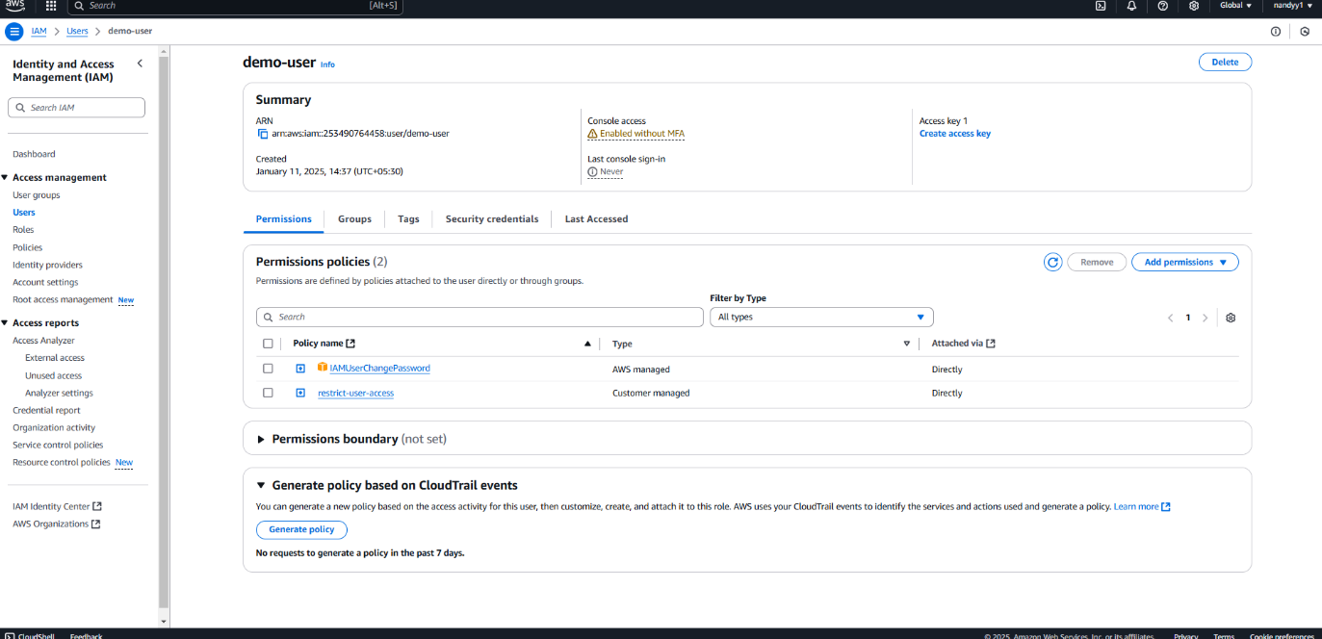

\

Step7: Once the policy had been created go to the iam user and see how many instance running in the particular region so the action had been seen in the region by adding the permissions

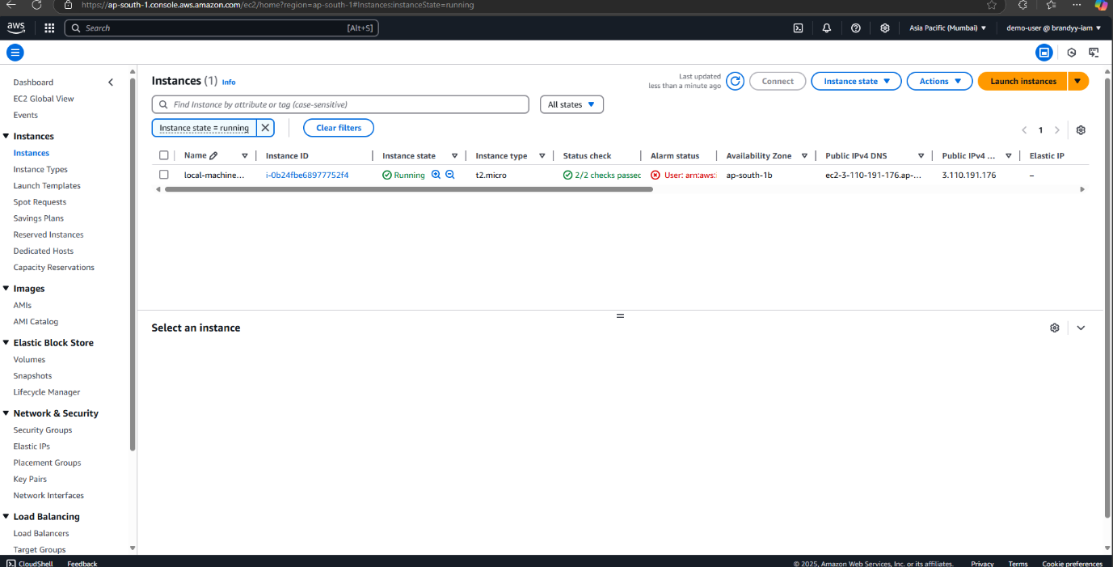

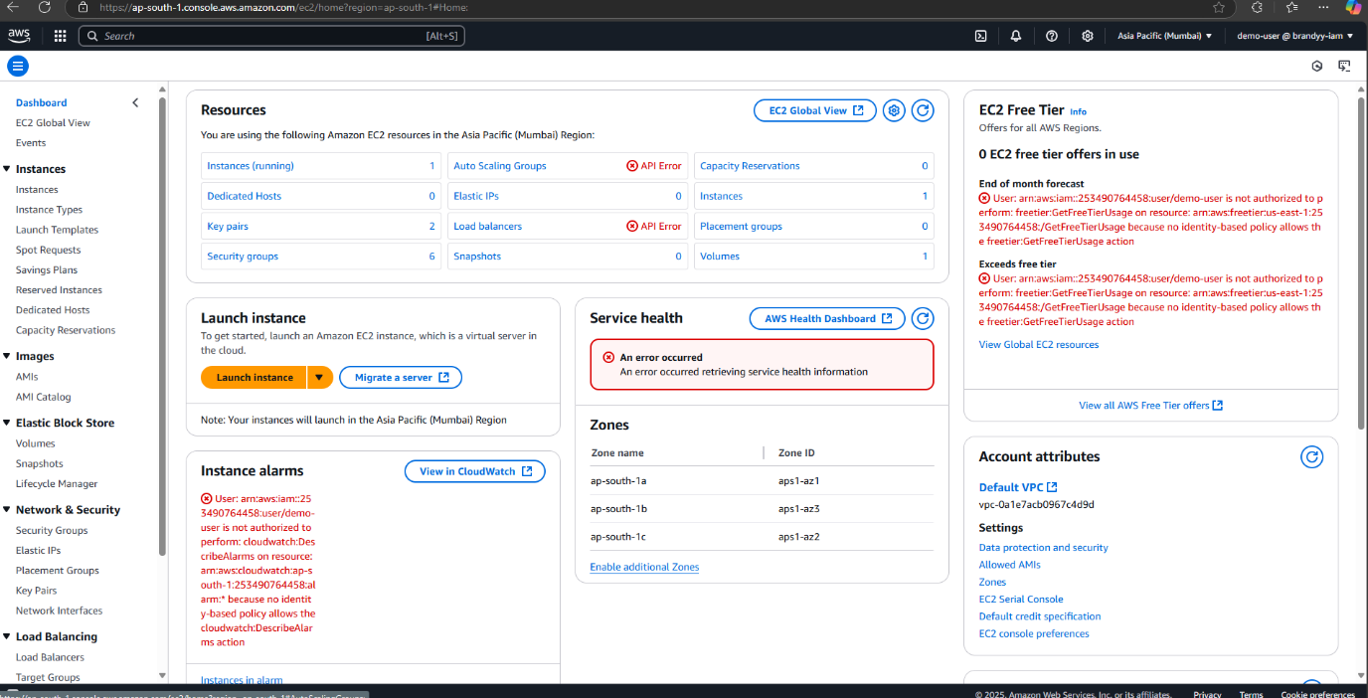

In the different region it cant be seen

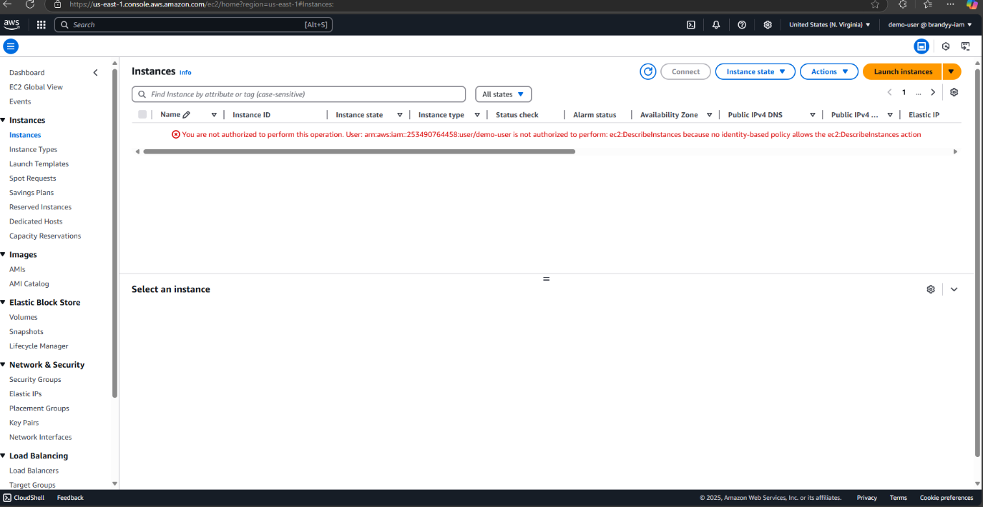

The output for the task 10 had been done

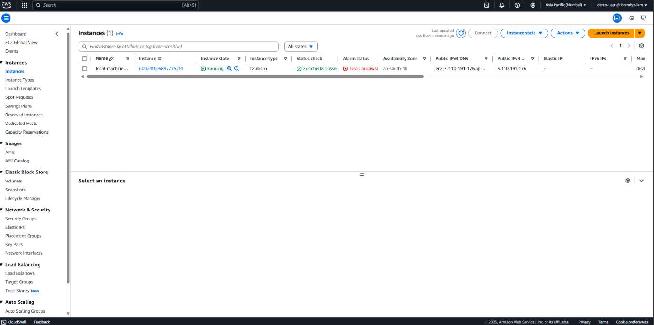

T***ask 11: Mount 2gb of volume in linux instance***

Step1 : Create an ec2-instance and the volume will be created along with the instance

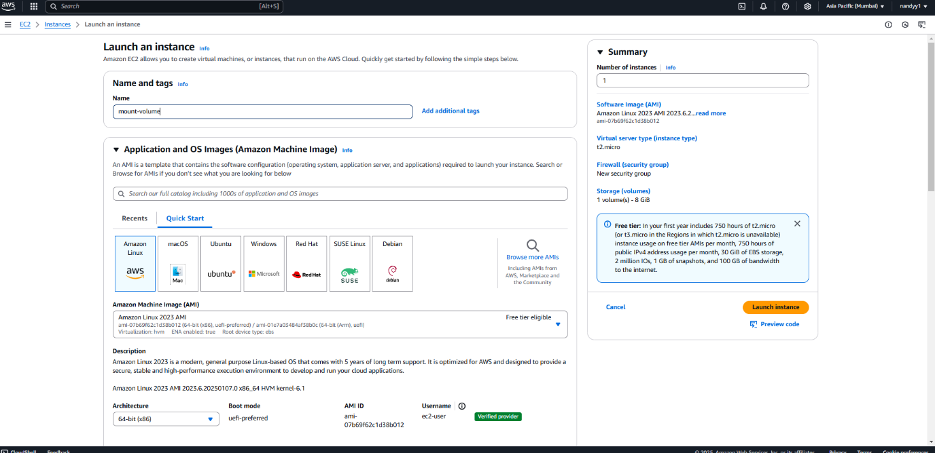

Step 2: Create a volume and attach the instance

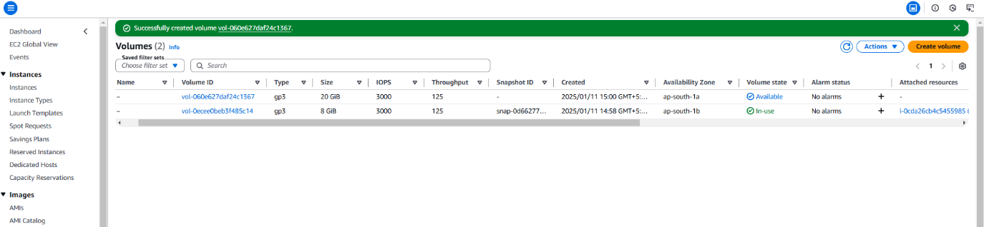

Step 3: attach the volume to the ec2 instance

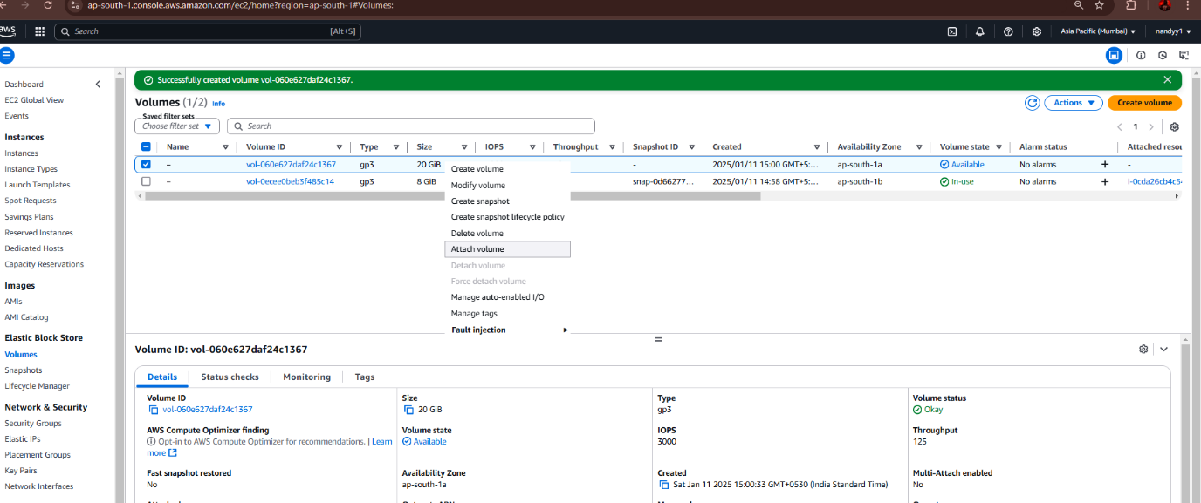

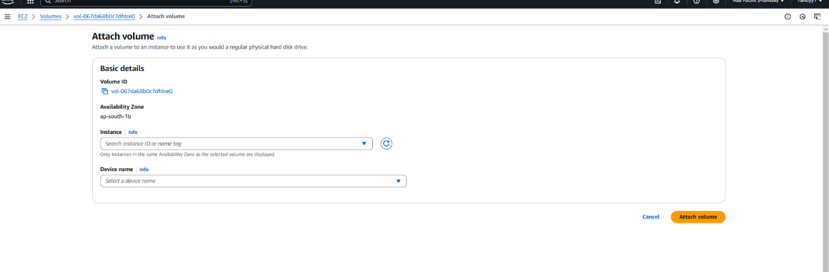

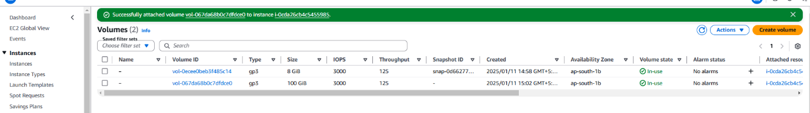

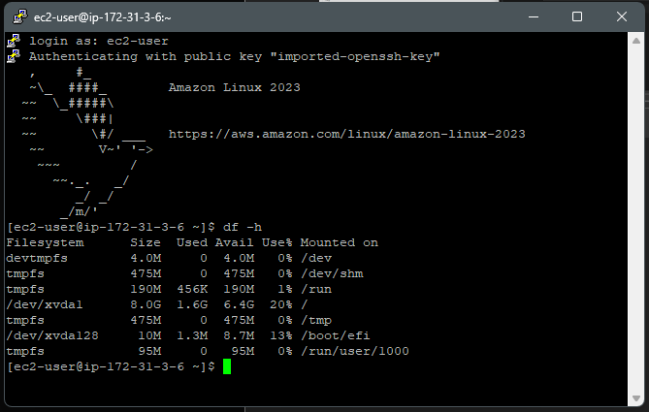

Step4 : Enter the following commands on the CLI

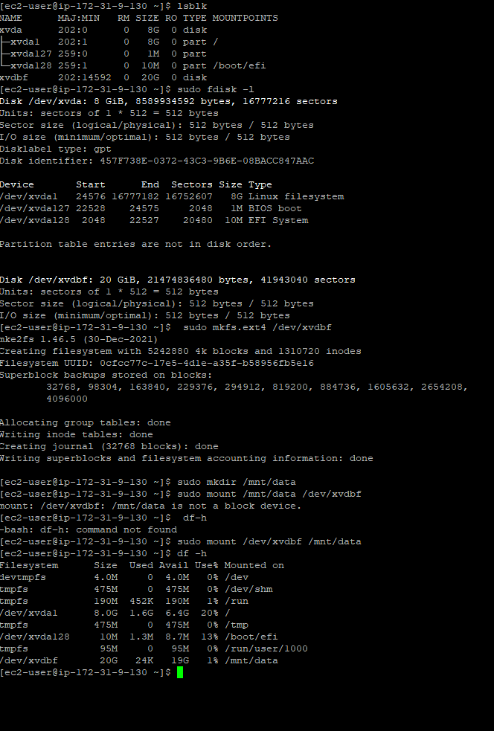

***Task 12. Use any alternative tool than putty to connect linux instance***

Step 1 – download Termius

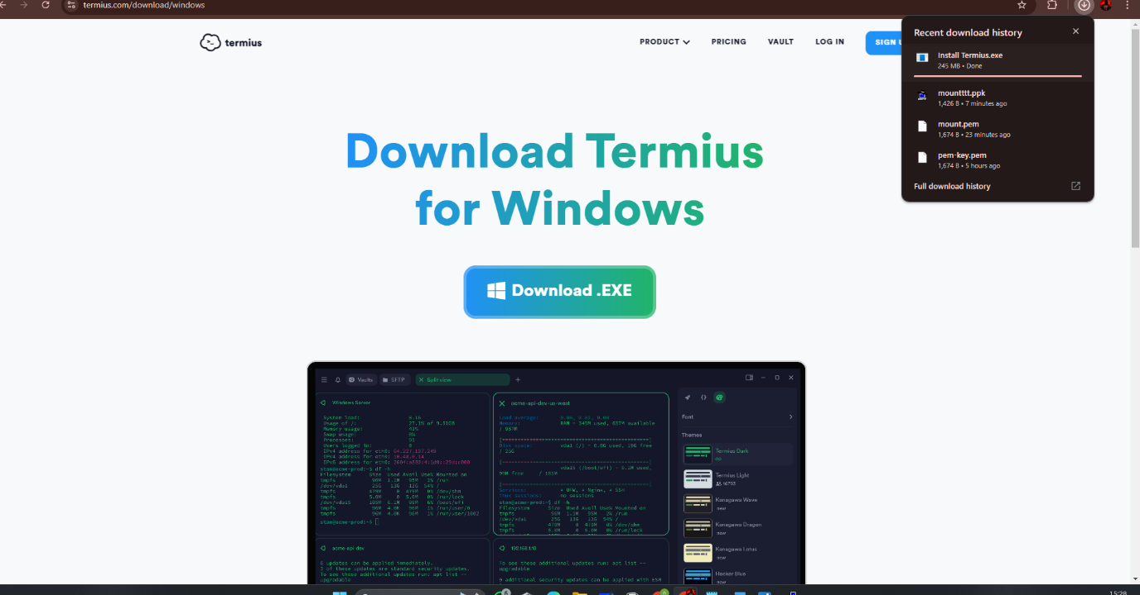

Step -2 go into the termius

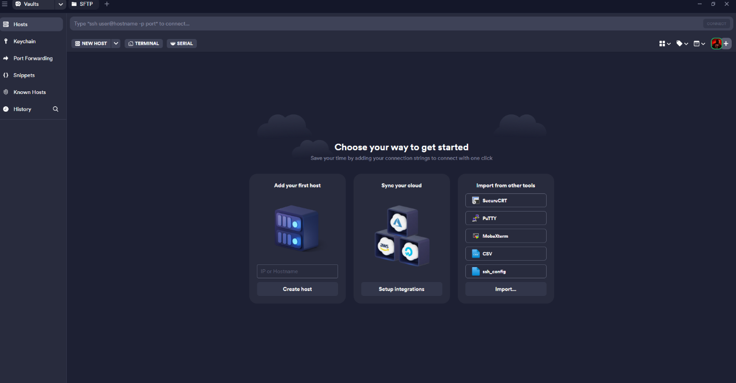

Step-3 On the right side of the termius there will be a set of options enter the user name -> as ec2-user and password as .ppk file

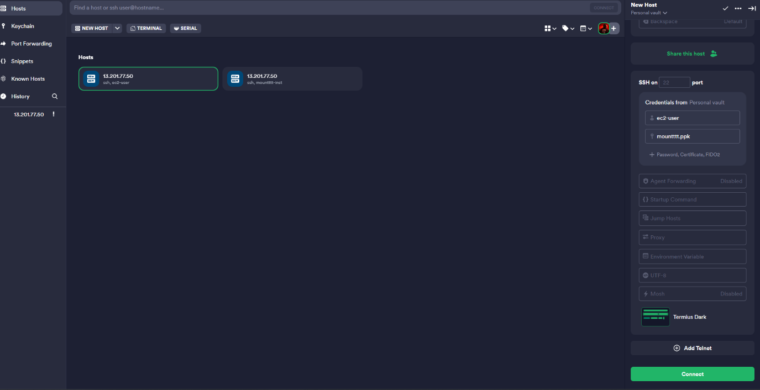

Terminal is opened so this the alternative for putty

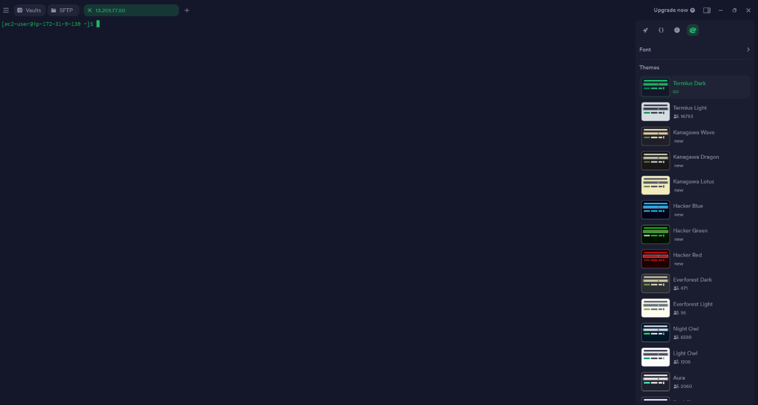

***Task 13 . what are different purchase model of EC2 instance***

13) what are different purchase model of EC2 instance

The purchase model in Amazon EC2 defines how you pay for and manage the compute

resources you use. AWS offers different pricing and commitment options for EC2

instances to cater to various workload types, budget constraints, and operational flexibility.

These purchase models allow you to optimize costs while ensuring your workloads have

the required compute capacity.

Different types of purchase model of EC2 instance

1. On-Demand Instances

* Payforcompute capacity per second or hour without long-term commitments.
* Best for applications with short-term or unpredictable workloads.

Key Features:

* Highly flexible: Scale up/down as needed.
* Noupfront payment required.
* Charged at a fixed rate per second or hour.

Use Cases:

* Development and testing environments.
* Applications with unpredictable demand.
* Temporary workloads.

2. Reserved Instances (RIs)

Commit to a 1-year or 3-year term in exchange for significant cost savings (up to 72%

compared to On-Demand pricing).

Types of RIs:

* Standard RIs: Offers maximum discount but with limited flexibility to change

instance types.

* Convertible RIs: Allows you to exchange the instance type, OS, or tenancy with
* slightly lower discounts.

Key Features:

* Requires upfront payment, partial upfront payment, or no upfront payment.
* Ideal for steady-state workloads.

Use Cases:

* Long-term, predictable workloads.
* Applications running 24/7, like web servers or databases.

3. Spot Instances

* Utilize unused EC2 capacity at up to 90% lower cost than On-Demand instances.
* AWS can terminate these instances with a 2-minute notice if the capacity is

reclaimed.

Key Features:

* Highly cost-effective.
* Instances can be interrupted, so workloads must be fault-tolerant.

Use Cases:

* Bigdata analytics.
* Batch processing.
* Continuous Integration/Continuous Deployment (CI/CD) pipelines.

4. Savings Plans

Flexible pricing model that provides cost savings (up to 66%) in exchange for a

commitment to a specific usage amount ($/hour) over 1 or 3 years.

Key Features:

* Flexibility to change instance types and regions with the Compute Savings Plan.
* Predictable billing.

Use Cases:

* Long-running workloads with some flexibility in instance type or region.

5. Dedicated Hosts

Rent a physical server dedicated to your use, giving you control over instance placement.

Key Features:

* Ideal for compliance or regulatory needs (e.g., HIPAA, PCI DSS).
* Bring Your Own License (BYOL) support.

Use Cases:

* Regulatory or compliance-driven applications.
* Applications requiring isolation from other AWS customers.

6. Dedicated Instances

EC2 instances that runonsingle-tenant hardware, isolatingyourworkloads fromother

customers.

KeyFeatures:

* Noupfrontcostorlong-termcommitment.
* ProvidesalevelofhardwareisolationsimilartoDedicatedHosts.

UseCases:

* Applications needing some level of isolation but not full control of hardware

placement.

***Task 14 -> Tabulate 50 protocals with port number***

|  |  |  |  |  |
| --- | --- | --- | --- | --- |
| HTTP | 80 | |  | | --- | | HyperText Transfer Protocol |  |  | | --- | |  | |
| HTTPS | 443 | |  | | --- | | HTTP Secure |  |  | | --- | |  | |
| FTP | 21 | |  | | --- | | File Transfer Protocol |  |  | | --- | |  | |
| FTPS | 990 | |  | | --- | | FTP Secure |  |  | | --- | |  | |
| SFTP | 22 | |  | | --- | | SSH File Transfer Protocol |  |  | | --- | |  | |
| SSH | 22 | |  | | --- | | Secure Shell |  |  | | --- | |  | |
| Telnet | |  | | --- | | 23 |  |  | | --- | |  | | |  | | --- | | Remote Login Protocol |  |  | | --- | |  | |
| SMTP | 25 | |  | | --- | | Simple Mail Transfer Protocol |  |  | | --- | |  | |
| SMTPS | 465 | |  | | --- | | Secure SMTP |  |  | | --- | |  | |
| POP3 | 110 | |  | | --- | | Post Office Protocol v3 |  |  | | --- | |  | |
| POP3S | 995 | |  | | --- | | Secure POP3 |  |  | | --- | |  | |
| IMAP | 143 | |  | | --- | | Internet Message Access Protocol |  |  | | --- | |  | |
| IMAPS | 993 | |  | | --- | | Secure IMAP |  |  | | --- | |  | |
| DNS | 53 | |  | | --- | | Domain Name System |  |  | | --- | |  | |
| DHCP | |  | | --- | | 67, 68 |  |  | | --- | |  | | |  | | --- | | Dynamic Host Configuration Protocol |  |  | | --- | |  | |
| TFTP | 69 | |  | | --- | | Trivial File Transfer Protocol |  |  | | --- | |  | |
| SNMP | |  | | --- | | 161, 162 |  |  | | --- | |  | | |  | | --- | | Simple Network Management Protocol |  |  | | --- | |  | |
| RDP | 3389 | |  | | --- | | Remote Desktop Protocol |  |  | | --- | |  | |
| |  | | --- | | VNC |  |  | | --- | |  | | 5900 | |  | | --- | | Virtual Network Computing |  |  | | --- | |  | |
| NTP | 123 | |  | | --- | | Network Time Protocol |  |  | | --- | |  | |
| LDAP | 389 | Lightweight Directory Access Protocol |
| LDAPS | 636 | |  | | --- | | Secure LDAP |  |  | | --- | |  | |
| SIP | 5060 | |  | | --- | | Session Initiation Protocol |  |  | | --- | |  | |
| SIPS | 5061 | |  | | --- | | Secure SIP |  |  | | --- | |  | |
| |  | | --- | | RTP |  |  | | --- | |  | | |  | | --- | | 5004, 5005 |  |  | | --- | |  | | |  | | --- | | Real-time Transport Protocol |  |  | | --- | |  | |
| RTSP | 554 | |  | | --- | | Real-Time Streaming Protocol |  |  | | --- | |  | |
| SMB | 445 | |  | | --- | | Server Message Block Protocol |  |  | | --- | |  | |
| |  | | --- | | NetBIOS |  |  | | --- | |  | | |  | | --- | | 137-139 |  |  | | --- | |  | | |  | | --- | | NetBIOS Name Service, Datagram, and Session |  |  | | --- | |  | |
| ICMP | |  | | --- | | N/A |  |  | | --- | |  | | |  | | --- | | Internet Control Message Protocol |  |  | | --- | |  | |
| IGMP | |  | | --- | | N/A |  |  | | --- | |  | | |  | | --- | | Internet Group Management Protocol |  |  | | --- | |  | |
| BGP | |  | | --- | | 179 |  |  | | --- | |  | | |  | | --- | | Border Gateway Protocol |  |  | | --- | |  | |
| OSPF | 89 | |  | | --- | | Open Shortest Path First |  |  | | --- | |  | |
| IPsec | 500 | |  | | --- | | Internet Protocol Security (IKE) |  |  | | --- | |  | |
| GRE | 47 | |  | | --- | | Generic Routing Encapsulation |  |  | | --- | |  | |
| L2TP | 1701 | |  | | --- | | Layer 2 Tunneling Protocol |  |  | | --- | |  | |
| PPTP | 1723 | |  | | --- | | Point-to-Point Tunneling Protocol |  |  | | --- | |  | |
| MySQL | 3306 | |  | | --- | | MySQL Database Service |  |  | | --- | |  | |
| PostgreSQL | 5432 | |  | | --- | | PostgreSQL Database Service |  |  | | --- | |  | |
| |  | | --- | | MS SQL Server |  |  | | --- | |  | | 1433 | |  | | --- | | Microsoft SQL Server |  |  | | --- | |  | |
| MongoDB | 27017 | |  | | --- | | MongoDB Database Service |  |  | | --- | |  | |